’94 F-150 Running Boards

By

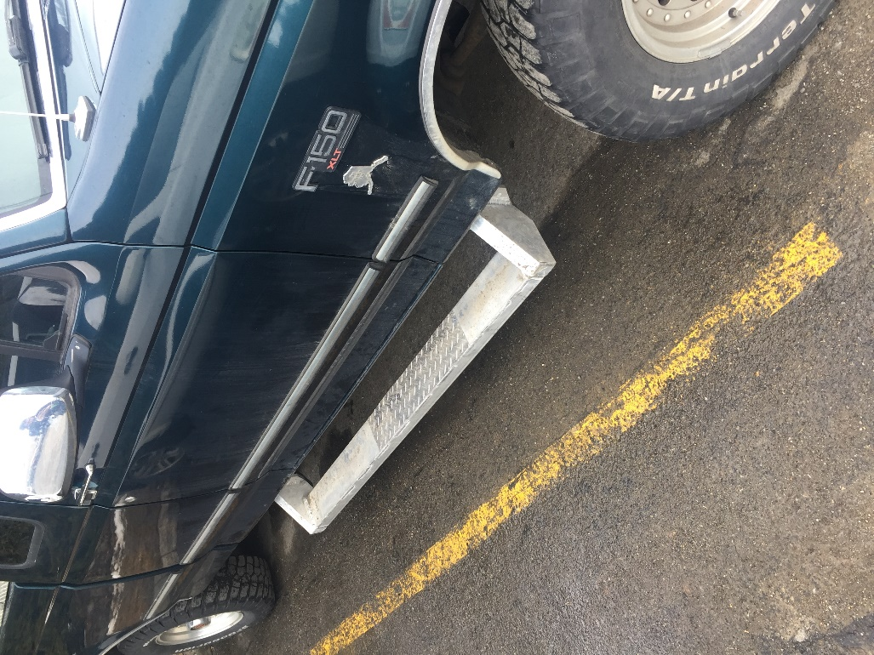
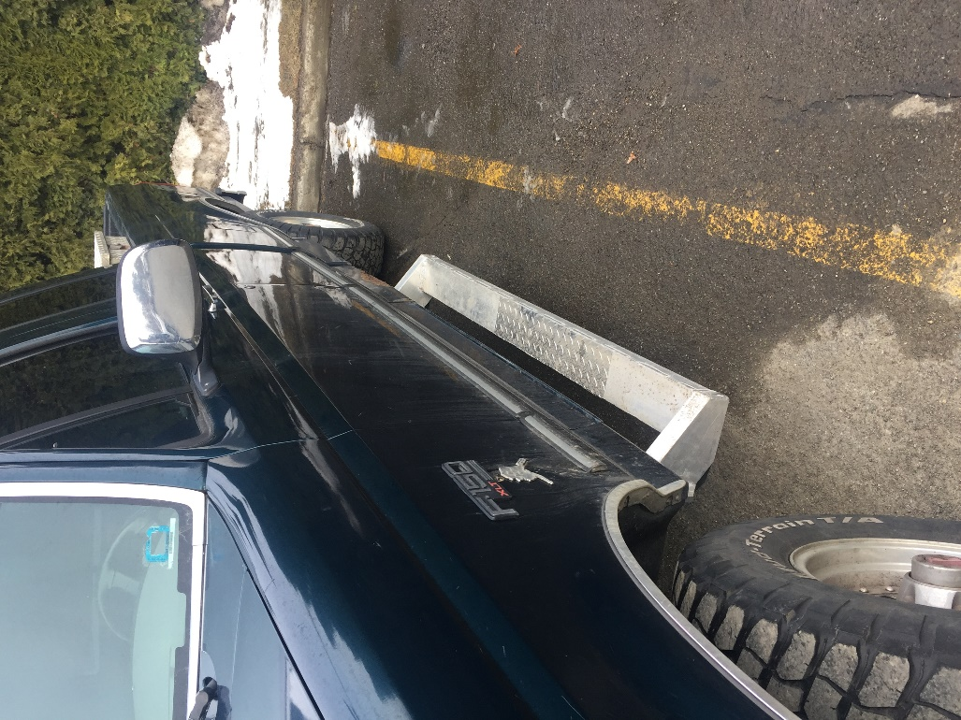
Justin Wies

Table of Contents
Table of Contents 2
INTRODUCTION 5
Motivation 5
Function Statement 5
Device Requirements 5
Success Criteria 5
Scope 5
Success of the Project 5
Design 6
Approach 6
Design description 6
Fig. 1 6
Benchmark 7
Performance Predictions 7
Description of Analyses 8
Scope of Testing and Evaluation 8
Analyses 8
Device Assembly 8
Tolerances 9
Safety Factor 9
Method and Construction 9
Construction 9
Parts List 9
Manufacturing Issues 10
Testing Method 10
Test Plan 10
Test documentation 10
Budget and Cost 12
Budget of parts 12
Labor 13
Total Cost 13
Funding 13
Proposed Schedule 13
Tasks 13
Deliverables 14
Total Project Time 14
Project Management 14
Human Resources 14
Physical Resources 14
Soft Resources 15
Financial Resources 15
Discussion 15
Project Evolution 15
Risks 16
Successes 16
Next Phase 16
Conclusion 16
Acknowledgements 16
References 18
Appendix A: Green sheets 19
A1: Top Impact 19
A2: Side Impact 20
A3: Bottom Impact 21
A4: Bolt Tensile Strength 22
A5: Bolt Shear Strength 23
A6: Bending Moment 24
A7: Bending Moment 25
A8: Bending Moment 26
A9: Moment of Inertia I_{y} 27
A10: Neutral Axis (NA_{x}) 28
A11: Moment of Inertia I_{x} 29
A12: Maximum Moment of Inertia, I_{x} & I_{y} 30
A13: Shear Stress in Side 31
A14: Shear Stress in Mount 32
A15: Maximum Bending Stress σ_{x} 33
A16: Maximum Bending Stress σ_{y} 34
A17: Conservation of Energy Attempt 35
Appendix B: Drawings 36
B1: Step Base 36
B2: Side 37
B3: Support 38
B4: Mount 39
B5: 1’ Flat Bar 40
B6: 2’ Flat Bar 41
B7: Diamond Plate 42
B8: Rear Support 43
B9: Step Base Assembly 1 44
B10: Step Base Assembly 2 45
B11: Side and Mount Assembly 46
B12: Assembled Device 47
Appendix C: Parts List 48
Appendix D: Budget 49
Appendix E: Schedule 50
E1: Fall Quarter 50
E2: Winter Quarter 51
Appendix J: Resume 52

INTRODUCTION

Motivation
The proposed device is needed because it is difficult to enter the truck without help from others. This project will be a combination of running boards and rock bars. The device will also protect the truck from impacts from the side, from the bottom and from the top. With the proposed device it would be significantly easier and quicker to access the truck, while protecting the truck from typical impacts.

Function Statement
The device must allow access to the truck without complaints and protect the truck from impacts from the side, top, and bottom while keeping weight to a minimum.

Device Requirements
The following are the design requirements for the proposed device. Some have been changed and modified and some have been added since the beginning of the quarter. These design requirements will ensure the device fulfills the function statement.
- Weighs less than 35lbs (each)
- Cost less than $500 (Appendix D)
- Can withstand an impact of 994.58 lbs_{f} on top (Appendix A1)
- Can withstand a side impact of 1356.1 lbs_{f} (Appendix A2)
- Can withstand an impact from below of 1439.84 lb_{f} (Appendix A3)

Success Criteria
Success criteria consists of the device allowing access to the truck without complaints and satisfies all the design requirements. This includes not yielding from the impulse forces of the various impacts described. There will be deflection after the impacts, but as long as the material doesn’t show significant change in shape from the loads then the device will be successful.

Scope
The scope of this project will be everything from design, to manufacturing, to testing. The first steps will be to measure the truck and decide where the step should sit. Then the first draft of the design will be made and calculations will be made to calculate the necessary dimensions to support the load. Then the device will be manufactured and then it will be fitted to the truck. Lastly it will be tested using the techniques described in later sections.

Success of the Project
The success of this project will be if I am able to combine rock bars and running boards into this impressive device. Quantitatively the success will be based on the final product’s ability to hold an impact of 994.58lbs from above, a side impact of 1356lbs_{f}, an impact from below of 1439lbs_{f}, weigh less than 35 pounds each, and cost less than $500 to manufacture. If the device is manufactured and satisfies these criteria then the device will be considered successful.

Design

Approach
The design was conceived based on the specifics of a 1994 Ford F-150. Is was designed to be mounted directly to the truck with minimal modifications to the truck. There were multiple revisions made to the design based on finances and changes in requirements.

Design description
The design consists of a step base, the top and the supports, the sides and the mounts. Most of the components will be welded together, however the mounts will be bolted to the steel cab of the truck using six, 1 inch A325 steel bolts. All the components will be made out of 6061-T6 aluminum alloy. The assembled device can be seen below in Fig. 1 and in appendix B12.
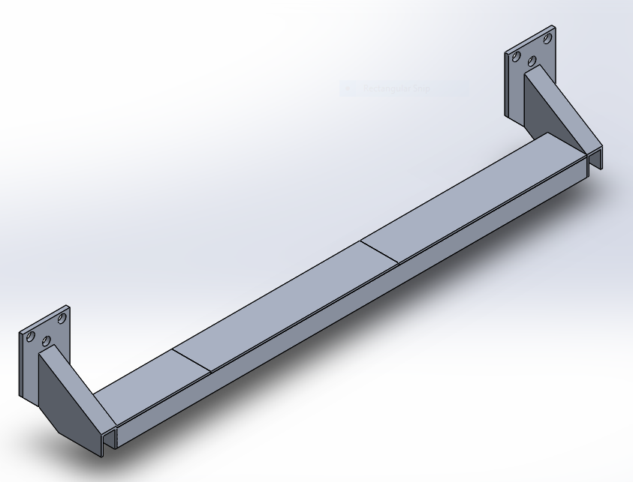

Fig. 1
  - Design of Step
The design started off being a half-pipe with diamond plating over the top. That design was quickly abandoned due to the fact that having a 5in diameter pipe would have the bottom of the device closer to the ground than desired. The design shifted to a 2” x 5” square tubing to get the width needed and keep the desired ground clearance. That design eventually was rejected due to the necessity to add reinforcements in the center of the step. So the design was then changed to channel tubing so that the reinforcements could be welded inside, then the step and covers can be welded over the top. The parts used in this sub assembly are shown in appendix B1, B3, B5, B6, and B7.

  - Design of Sides
The side started as 2” x 5” tubing cut to the correct angles to put the step in the desired position relative to the mounts. The design was changed to 2” by 3” tubing when the step was changed, however that did not give a long enough mounting side to weld the step to, so the design was reverted back to 2” x 5” square tubing. This part is shown in appendix B2.

  - Design of Mounts
The design for the mounts did not change much. The design always had the same shape and was always going to be made from ½ flat bar from the beginning. The only thing that changed in the mount design was the length. The length changed with the change in the sides to keep the step located in the desired position. This part is shown in appendix B4.
After further investigation the original mounting spots on the truck were not as rigid as originally thought to be. The project manager fixed this by designing supports that run from the bottom of the sides on the devices, back to the actual frame of the truck. They are bolted to the frame and the devices using the same mounting hardware used to mount the devices. These additional supports can be seen in Appendix B8.

Benchmark
A benchmark for this project is very hard to come up with because as research shows this is no such thing as a running board/ rock bar combination available on the market today that is able to withstand these kinds of impacts. The closest thing available is a bar that runs along the bottom of the door to “protect” it and it has two small steps at each door. This is not even close to offering the same level of accessibility as this device. With that device you must get your foot perfectly in the correct spot to be able to use the step. With the proposed device you can step anywhere within the 5 foot span and still be able to use it. The device mentioned available on the internet is advertised at $399, so it is slightly cheaper, but it offers much less accessibility.

Performance Predictions
The device is predicted to meet and exceed every design requirement. It will be built with strict enough tolerances and of the highest quality aluminum alloy to ensure the device will exceed all requirements. It will be welded with appropriate filler rod to meet structural requirements.

Description of Analyses
First the device will be mounted directly to the truck. The device will then have appropriate loads applied and the deflection will be recorded. Then those results will be correlated with the failure limits to ensure that it can withstand the loads, without actually applying the full loads.

Scope of Testing and Evaluation
The testing will test the device’s load capabilities. It will test the devices ability to withstand an impulse force from a person stepping on the top of the running board. It will test the devices ability to withstand and impulse force from a car hitting the side of the running board. And it will also test the devices ability to withstand an impulse force of high-centering the truck on one of the running boards.

Analyses
Appendix A1 shows the calculations for an impulse load of 400lbs. is shows that the impulse requires the device to withstand a force of 994.58lbs from above. Appendix A2 shows the impulse calculations for the side impact. It shows that the device must withstand a force of 1356.1lbs from the side. Appendix A3 shows the impulse calculations for an impact from below. It shows that the device must withstand a force of 1439.84lbs from the bottom. Appendix A4 shows the tensile force for the bolts from the bottom load. Appendix A5 shows the shear forces on the bolts generated by the bottom load. Appendix A6 shows the bending moment generated by the top load. Appendix A7 shows the bending moment for the impact from below. Appendix A8 shows the bending moment for the side impact. Appendix A9 is the calculations for the Moment of Inertia in the around the y-axis, I_{y}. Appendix A10 shows the calculation of the neutral axis in the x-axis. That was needed to calculate the moment of inertia in the x-axis, which is shown in Appendix A11. The moment of inertia in the x-axis was used to calculate the bending stress in the device to ensure the loads applied would not shear the device. The next page shows the maximum possible moment of inertia in appendix A12. This was used to quickly ensure that this project was possible. Appendix A13 shows the shear calculations for the side components. It uses the highest force to calculate the shear stress in the side tubing to ensure the side would not shear. Appendix A14 shows the shear stress calculations for the mount components. Appendix A15 shows the bending stress in the x-axis. It was proven that the device would not shear using a completely hollow device, so the maximum was unnecessary. Appendix A16 shows the bending stress in the y-axis. It proves that the bending stress will not exceed the ultimate shear stress of the material. Appendix A17 shows a calculation using the conservation of energy. This was proven to be insignificant as the calculation shows the “equivalent” static load for a 400lb person stepping on the device would be 8,348lbs. It was mutually concluded that using conservation of energy was inaccurate due to the losses in energy being neglected. Therefore the original way of calculating using momentum was used.

Device Assembly
The different components of the device will be welded together using TIG welding. The device will be attached to the cab of the truck using eight 3/8” Grade 5 bolts. The device can’t be welded to the truck because it is made out of 6061-T6 aluminum and the truck is made out of steel. The welds will be all the way across all seems to ensure the device has the structural integrity to exceed requirements.
Welding the supports to the inside of the c-channel proved to be extremely difficult, so the design was changed from 9 supports per step to 4 supports per step, spaced 1ft apart. To weld the supports to the c-channel around 220 amps were needed. To weld the sides to the mounts 320 amps were needed. To weld the covers to the top of the c-channel 275 amps were needed and to weld the side/mount assemblies to the step assemblies 260 amps were needed.

Tolerances
The tolerances will have to be fairly tight. The tolerances can’t be completely decided until the device is actually assembled. The tolerances are expected to be within .030” to ensure proper fit or within .005” to make the device look more appealing.

Safety Factor
The safety factor for the bolts is close to 10. The safety factor for the mounts is 132.7. the safety factor for the side impact is 6.08. The safety factor for the sides is 96.4. The safety factor for the bottom impact is 2.93. This means the absolutely lowest safety factor for this device is 2.93, almost 3.

Method and Construction

Construction
First all the parts for the step base will be cut to the correct length. Then the sides will be cut to length and cut to the correct shape. Then the base will be welded to the sides using TIG welding. Next the supports will be cut to the right length and welded into their positions. Then the supports will be welded inside the base in their correct positions. Next the flat bar and diamond plate tops will be welded over the top of the base. Lastly the mounts will be welded to the sides.
After further investigation the original mounting spots on the truck were not as rigid as originally thought to be. The project manager fixed this by designing supports that run from the bottom of the sides on the devices, back to the actual frame of the truck. They are bolted to the frame and the devices using the same mounting hardware used to mount the devices. These additional supports can be seen in Appendix B8.

Parts List
Below is a parts list to construct 2 devices (one for each side of the truck). A detailed description of the parts, cut lengths, quantities and prices can be found in Appendix C and Appendix D.
6061-T6 Rectangle Tube 2" x 5" x .25" | Sides
6061-T6 Extruded Channel 5" x 2.25" x .26" x .15" | Step Base
6061-T6 Extruded Flat Bar .25" x 5" | Step Cover
6061-T6 Extruded Flat Bar .5" x 6" | Mounts
6061-T6 Extruded Rectangle 1.5" x 4.5" | Supports
6061-T6 1/4" Aluminum Diamond Tread Deck Plate 12" x 24" | Step Cover
1" -8 x 3.5" Heavy Hex Bolt and Nut A325 (pack of 6) | Mounting Hardware
The final design did not use 1” diameter bolts due to space limitations on the truck. I used 3/8-16 x 1.25 Grade 5 bolts to mount the devices to the truck. The c-channel used was also slightly different than the c-channel listed due to the availability at the local supplier. The supports were also redesigned to cut costs and reduce weight while still providing the rigidity needed.

Manufacturing Issues
One of the manufacturing issues that may be encountered is the welding of the parts together will create heat in the Aluminum and might cause it to expand. Therefore the device will need to be clamped together before and while being welded that way the heat doesn’t cause expanding, misalignment and errors in dimensions. Another error that might occur in manufacturing is that when the pieces are welded the welds and the metal around the welds will not have the same strength as the material itself. This will be corrected by using proper welding techniques and appropriate safety factors to ensure those errors are negligible.

Testing Method

Test Plan
The device will be tested easiest once mounted to the truck. The running boards will be mounted to the truck as described and then the loads will be applied separately to ensure the device exceeds the design requirements. The original plan was to First the 400lb static load will be applied. Then the 198lb dynamic load will be applied. Then the 1300lb load will be applied to the side, using some sort of cushioning material to ensure there is no damage to the device and to simulate the deformation of the bumper. Lastly the load from below will be applied by jacking up one wheel of the truck by one of the running boards until the tire is completely off the ground. However after a significant amount of time, effort, and money was put into this project the test method has been changed. Now lesser, more appropriate loads will be applied and the deflection of the device will be measured. Then those results will be correlated with the failure limits to ensure they pass the requirements.

Test documentation
Some of the testing was done while the device was on the truck, while some of the testing required the device to be removed from the truck. The first test was to calculate a yield point for the top load by measuring the deflection of known loads and then correlating that into a yield load. First a load of about 60lbs was applied to the center of the device, then the deflection was measured using a dial indicator with a precision of .0005 of an inch. Then a load of around 120lbs was applied and the deflection was measured again. Lastly a load of around 230lbs was applied and the deflection was measured. This was repeated 3 times, then the average deflection for each load was calculated. Then a moment was calculated based on an experimental I value extracted from the data. The moment was then used to calculate the yield load. As shown in the first table, the yield load was calculated to be over 3000lbs, which gave a factor of safety of over 3.
The second test used the exact same procedure as the first. The only difference is that the device was removed from the truck, then put on its side so that the outside edge was facing upward, then the testing procedure began. As shown in the table below the yield point was over 4100lbs, which gave a factor of safety of over 3 again.
The third test had the same procedure as the first two. The only difference was that the device was removed from the truck and then put upside down so that the bottom side of the device was facing upward, then the testing procedure began. As shown in the table below the yield point was calculated at over 2400lbs, which gave the device a factor of safety of just over 1.7 for this requirement.
The final test was simple, before the device was installed back on the truck, a scale weight was taken to ensure it was under the required weight. As shown in the picture below, the device had a tare weight of 30.0lbs, which is 5lbs under the requirement of 35lbs.
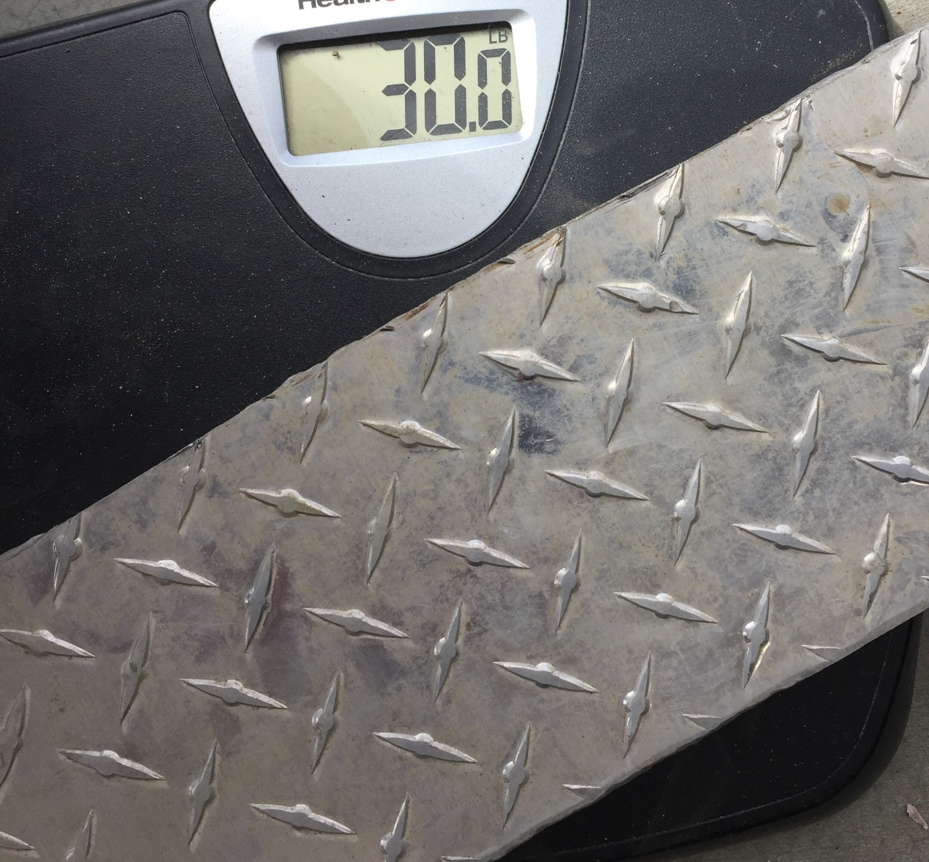

The device can withstand over 3 times the required load from the top. The device can withstand over 3 times the required load from the side, and the device can withstand over 1.7 times the required load from the bottom. The device cost $110 less to manufacture than projected, and combined the devices weigh 10lbs less than the maximum set in the requirements. Overall the device exceeded all requirements as was projected. The device is more than capable of handling all the loads it is designed to hold, it weighs less than the projected amount, and it cost less than the projected amount.

Budget and Cost

Budget of parts
The device will be made of 6061-T6 aluminum alloy as stated before. Initial price checks put the budget at just under $500. Most of the parts were prices at OnlineMetals.com, but soon local suppliers will be checked to get the best prices. Appendix D shows a detailed parts list with preliminary prices.
The devices were built in well under budget at $387. This included all the material for the devices, the material for the supports (which was free), and the mounting material.

Labor
The total cost does not include welding costs or the very little machining costs. These are excluded due to the fact that all that will either be privately done at the school labs by the project manager. The whole device will be TIG welded at the school using the welding lab. The Lab Techs will allow the use of the welding lab with ample time to complete the devices
I built this entire project by myself. From design and calculations to the manufacturing of these devices it is solely my work. However, I did ask for advice and opinions from multiple people including but not limited to, Sean, Matt, Mr. Beardsley and Stefan. This project took a total of 63.5 hours to manufacture, which is slightly below the projected amount of 75.6 hours.

Total Cost
Preliminary checks put the budget at $467.48. This includes all the aluminum for two running boards and the hardware to mount the running boards to the truck. However that is expected to be significantly less after local sources are checked.
After the devices were built I came in well under budget at $387. This included all the material for the devices, the material for the supports (which was free), and the mounting material.

Funding
The whole project is planned to be funded by the project manager, Justin Wies. The devices will be going on his truck and he will be the sole beneficiary of this project. Justin plans to look for donations from relatives to help found his project, but he plans on working a lot of hours to be able to pay for this device.

Proposed Schedule
The schedule has been changed multiple times. In week four the project was almost cancelled out of nowhere. The Board of Advisors suddenly saw no engineering merit in the project. A week was wasted while convincing the Board otherwise. Shortly after that the project changed to include many more design requirements to ensure enough green sheets would be produced. At the end of week six, the project almost changed again when the Board decided the way the calculations were made needed to be different. So another week was wasted there determining that the Board was wrong. These changes are explained better in the Discussion section.

Tasks
The first task was to come up with a project idea. The project idea was thought of well before this quarter started so the time it took to come up with the idea was very short. The next task was to start on the introduction. This took way longer than it should have because the Board of Directors were unprepared, inconsistent and unclear. Next was to design and analyze the device. This took significantly longer than it should have because the device ended up getting over complicated. Therefore the design had to be revised and extra calculations had to be made. The next step was the Methods & Construction section of the proposal. This took slightly longer than it should have but only due to slight revisions. Testing Methods came next, the testing methods are going to be more complicated than they should have due to the extra unnecessary design requirements. The budget and schedule was after that. The only thing that was affected was the schedule. It was affected by the multiple changes in the project. The discussion has not been done yet and neither has the conclusion. The documentation and appendix have been being worked on the whole time and will take extra time due to the changes in the project. A specific schedule can be seen in Appendix E on the Gannt chart.

Deliverables
The parts shown in the drawing in appendix B. Each one will be an appropriate deliverable and a significant milestone for this project. The first deliverables will be all the parts cut to the correct length. The second set of deliverables will be the small amount of CNC machining taken care of. The third set of deliverables will be all the different components welded together correctly. The final deliverable will be the device mounted to the truck.

Total Project Time
The estimated total time for this project is shown in Appendix E. It is estimated to take 75.6 hours. The final amount will be significantly more due to the unnecessary complications, unneeded attempts to change and the complications in manufacturing.

Project Management

Human Resources
One of the main resources for this project will be Mr. Bramble. He has extensive knowledge in machining and the production of parts. He will be able to answer any questions I may have about the manufacturing of this device. Another important resource is Mr. Burvee. He is the head lab tech at CWU and will assist in the ordering of parts, and the welding of the device. Two more important resources in this project are Mr. Kastning and Mr. Schacht. They are both lab techs who will assist by making sure the project manager has ample time in the labs to produce the device.

Physical Resources
The most important physical resource for this project will be the TIG welder in the welding lab at CWU. It will be necessary for the vast majority of the assembly of the device as the device is made entirely of 6061-T6 aluminum. Another physical resource is the CNC machine in the machining lab. This will ensure the mounts are made with tight tolerances. There will also be a slight need for insignificant hand tools such as a drill to drill out the holes for the mounts, wrench and ratchet sets to attach the device to the truck and possibly rubber seals to reduce vibration damage.

Soft Resources
The most important soft resource is SolidWorks. It was used to design the device, model the device, and to made calculations. Another software resource is Microsoft office, which was generously donated by Mr. Ryan Evans. Microsoft Office includes multiple useful products such as Excel, which was used for the scheduling and budgeting and Word, which was used to produce this proposal.

Financial Resources
Originally the project was going to be funded entirely by the project manager, Justin Wies. Now that the device has been made significantly more complicated, the project manager will be reaching out for donations from many sources. The project originally was going to be less than $200 to make both running boards for the truck. Now that the device is required to withstand significantly more than a standard running board due to the unnecessary added requirements, the cost has more than doubled. So it would be great to get some financial aid from people close to the project manager.

Discussion

Project Evolution
This project got off to a great start. It was known that this is what the project manager wanted to do for 2 months before school started. The project manager came to school, presented his idea the first week and it was immediately approved and it was agreed that impulse was the best was to calculate loads and to estimate the change in time. So the project manager continued along with his project while others continued to try and figure out what they would do for a project. With little to no feedback for the first few weeks the project continued all the way until week 4. Then out of nowhere the project manager was told that there is no engineering merit in this project. So after a week or so of discussions, it was concluded that the project would continue, but with significantly more difficult design requirements. Included withstanding a side impact of a car, and an impact from below of the truck itself. These changes really took a toll on the design. As it had to be redone using stronger and larger material to account for these higher loads. This is where most of the changes happened. After about week 7 the project manager had finally gotten the project back on track. Then at the end of week 8 the project manager was told to make his calculations using the conservation of energy method instead of impulse, which is what the project manager had been doing all along. It was explained multiple times that conservation of energy would not be a viable way to calculate the loads due to significant losses in energy that could not be calculated. These losses would be due to plastic deformation, noise, and heat generated. These are all significant losses of energy and the calculation method neglects all of these and assumes no losses in energy. However the project manager made a calculation with the conservation of energy method and it was concluded that the conservation of energy method was not relevant to this project. This calculation can be seen in appendix A17.

Risks
There are very few risks associated with this project. One of the only risks would be that if the device fails when somebody is on top of it, then somebody could be injured. This will never happen because the device will go through multiple tests to ensure it will not fail.

Successes
One success of this project is that in theory the device will pass all tests with flying colors, as it has safety factors of equal to or greater than 3. Another success is that the proposal is done and the project will continue as scheduled. The project was completed on time even with multiple unnecessary setbacks and delays.

Next Phase
The next phase of this project is to test the devices. This is outlined in the test section. Essentially smaller than expected loads will be applied, the deflection will be measured and then correlated with the failure points to ensure the devices pass the requirements.

Conclusion
This project is to create two devices that will allow access to a 1994 Ford F-150 with ease while also functioning as rock bars to protect the truck from impacts. These devices are called running board/rock bars. Two are needed, one for each side of the truck. The device will need to withstand an impact of 994.58lbs from the top, a side impact of 1356.1lb, and an impact from the bottom of 1439.84lb. When the device passes all of these tests it will ensure that the devices will sufficiently protect the truck and also allow easy access to the truck. The device will meet and exceed every test because the device is being built with tight tolerances and to the highest quality.
As the manufacture quarter comes to a close the requirements must be evauluted. The purpose of this quarter was to have a working device on the desk last Wednesday, the 8th of March. The devices were completed by the project manager 3 weeks previous to that and were mounted on the truck and supported by that time. So the second quarter of this project was a huge success.

Acknowledgements
The following are people the project manager would like to thank personally for their contributions to this project. These people have helped with everything from moral support and advice, to financial support and supplying resources.
- Mr. Roger Beardsley
- Mr. Charles Pringle
- Mr. Matt Burvee
- Mr. Arthur Morkin
- Mr. Sean Wies
- Mrs. Tracy Wies

References
Mech Design book

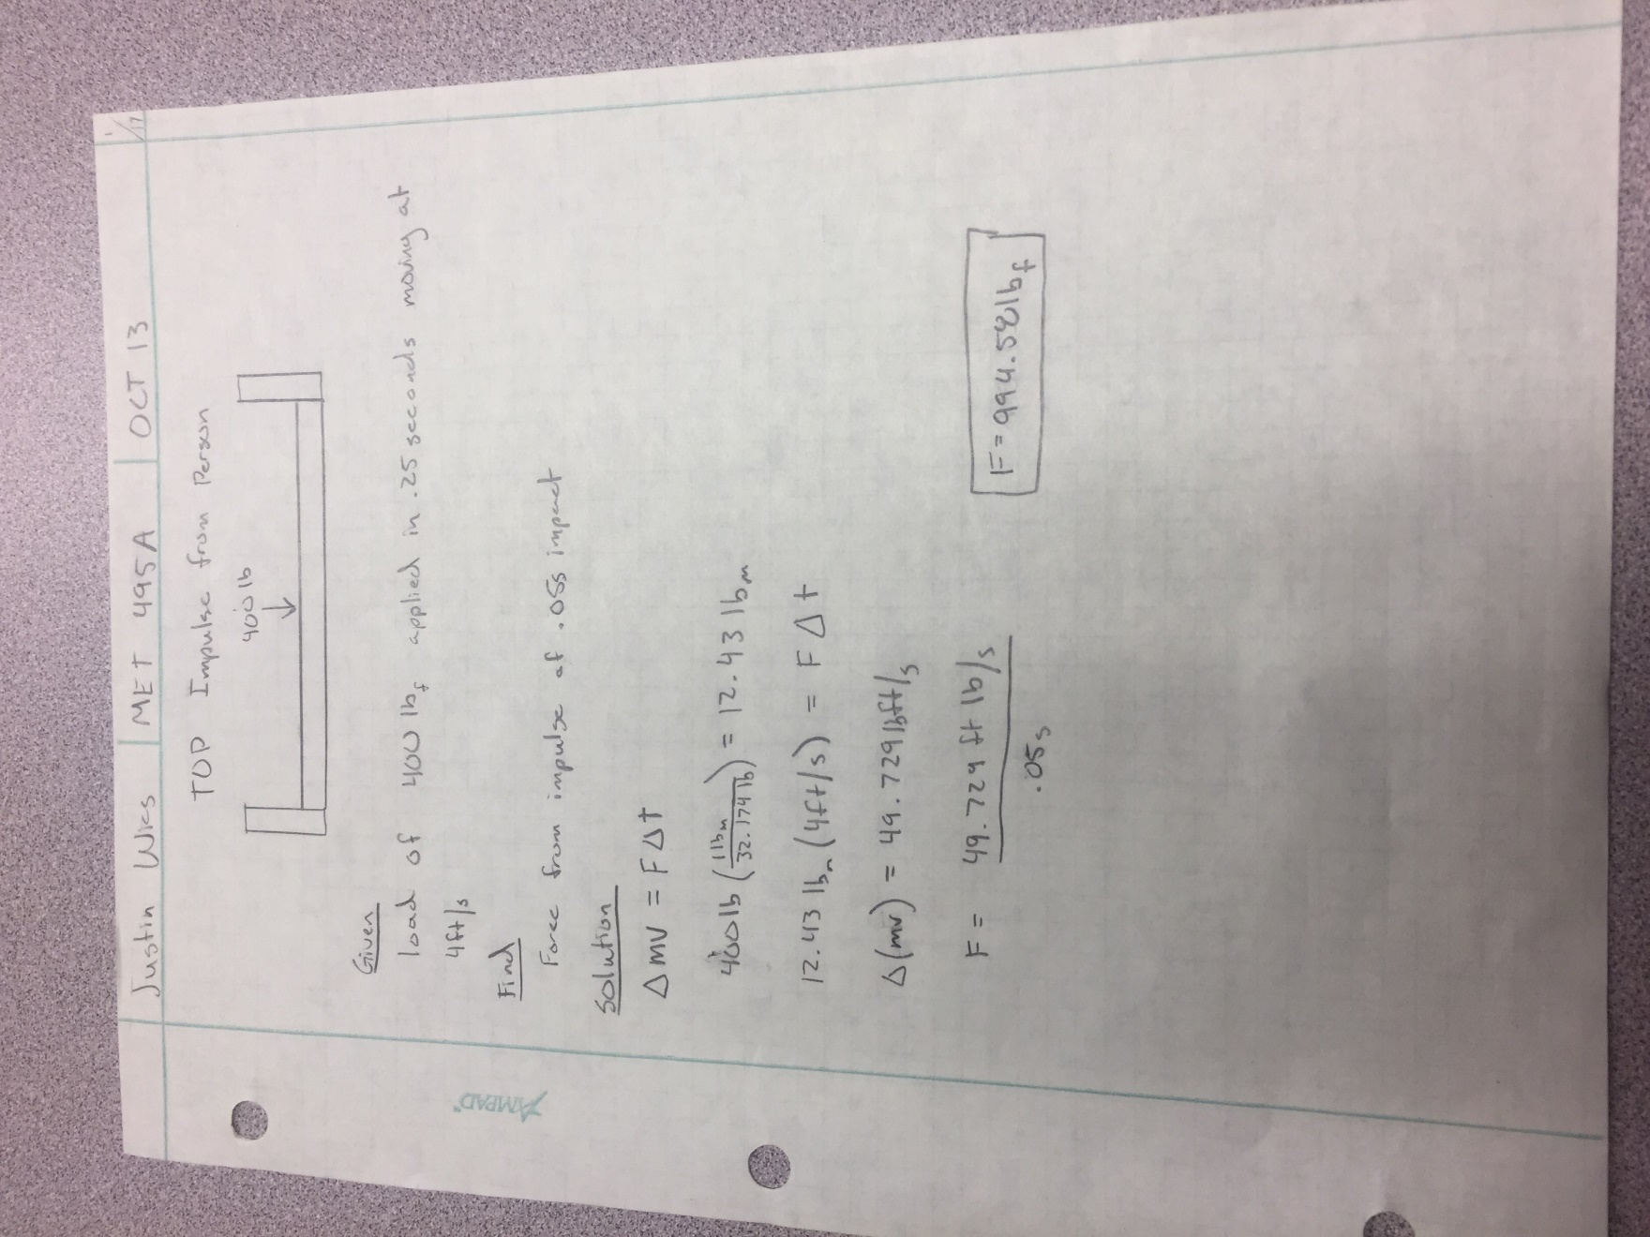
Appendix A: Green sheets

A1: Top Impact

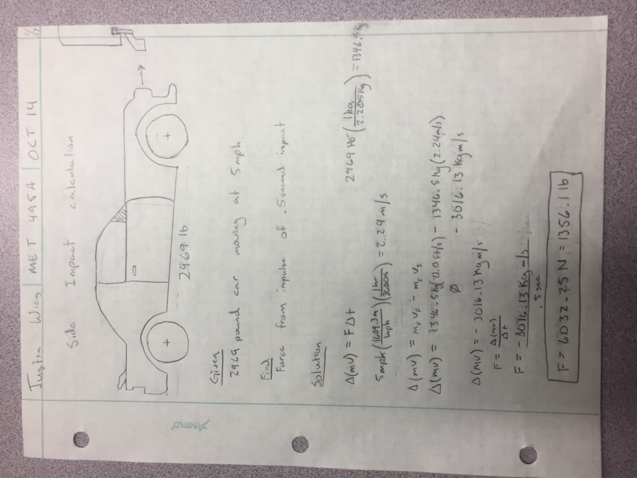
A2: Side Impact

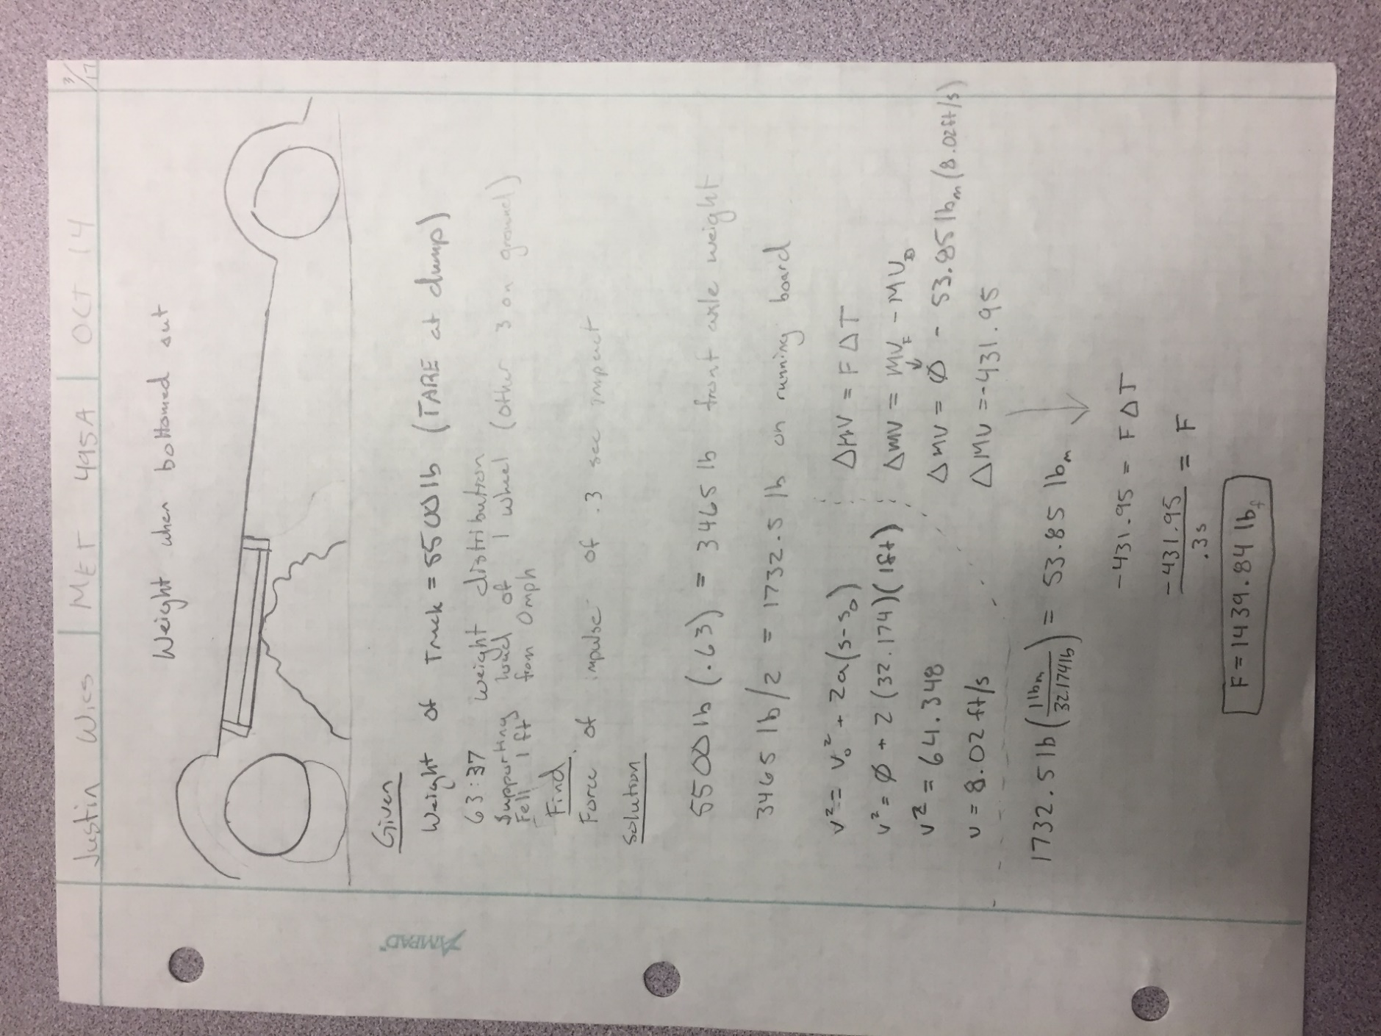
A3: Bottom Impact

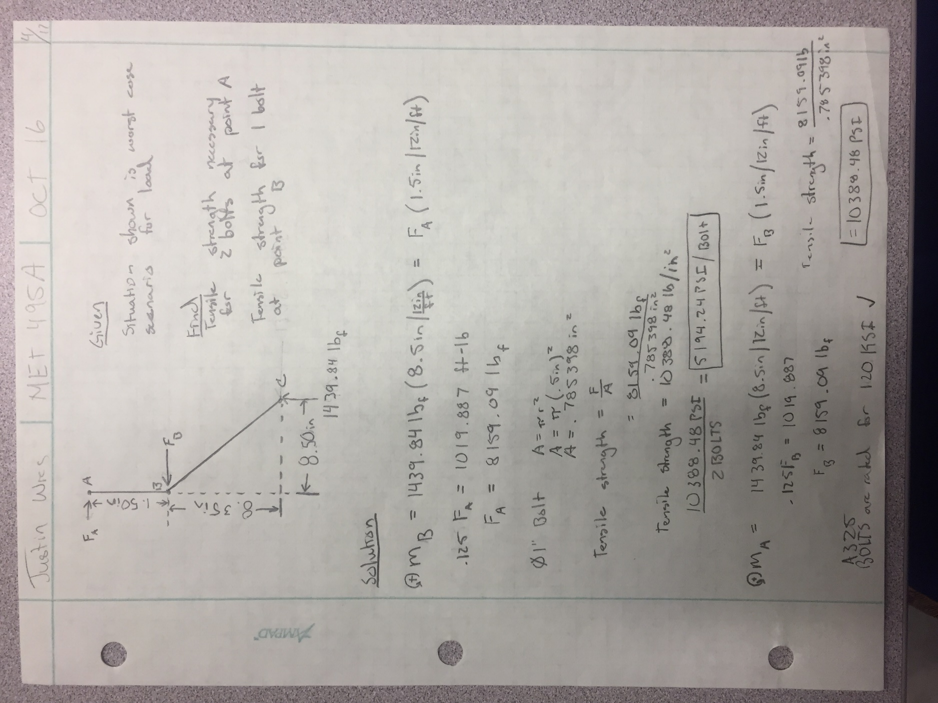
A4: Bolt Tensile Strength

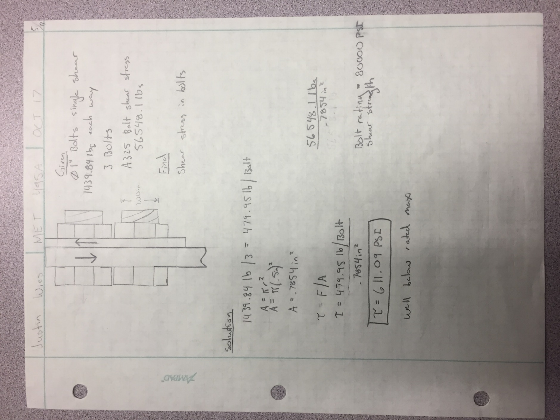
A5: Bolt Shear Strength

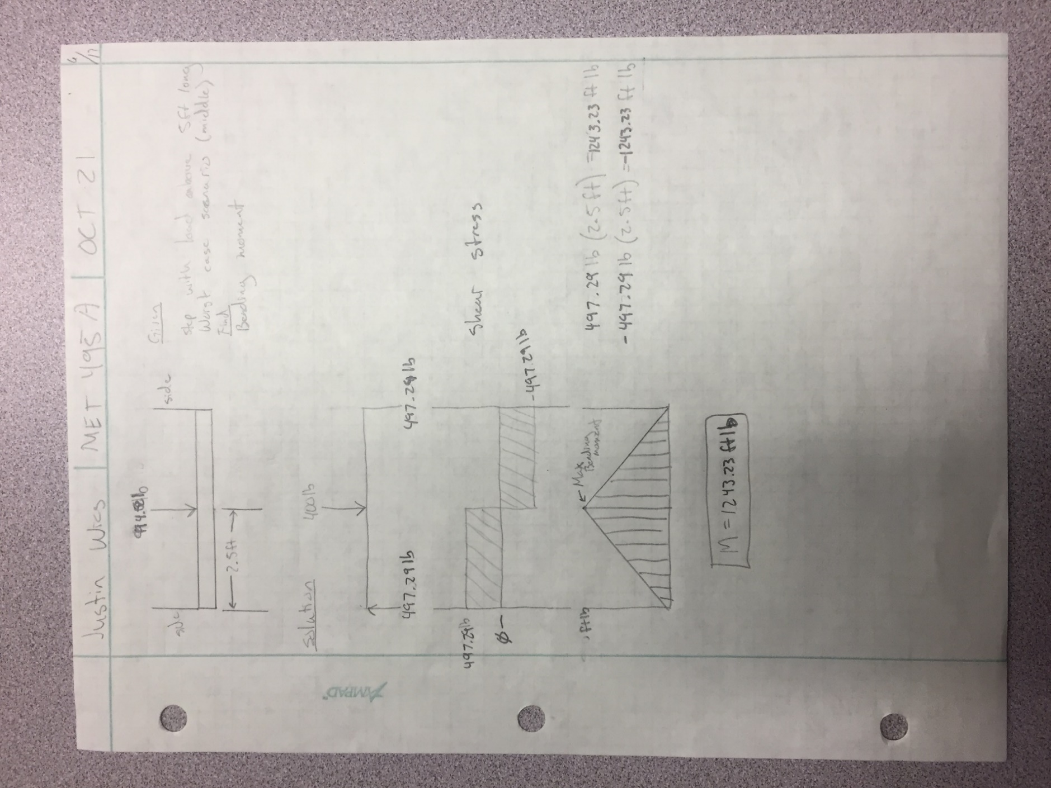
A6: Bending Moment

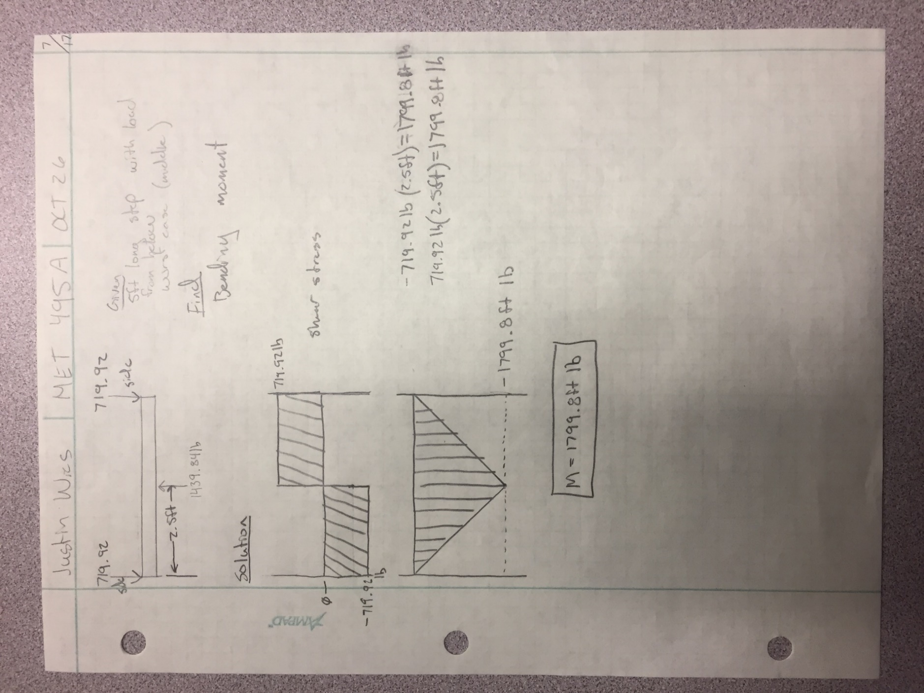
A7: Bending Moment

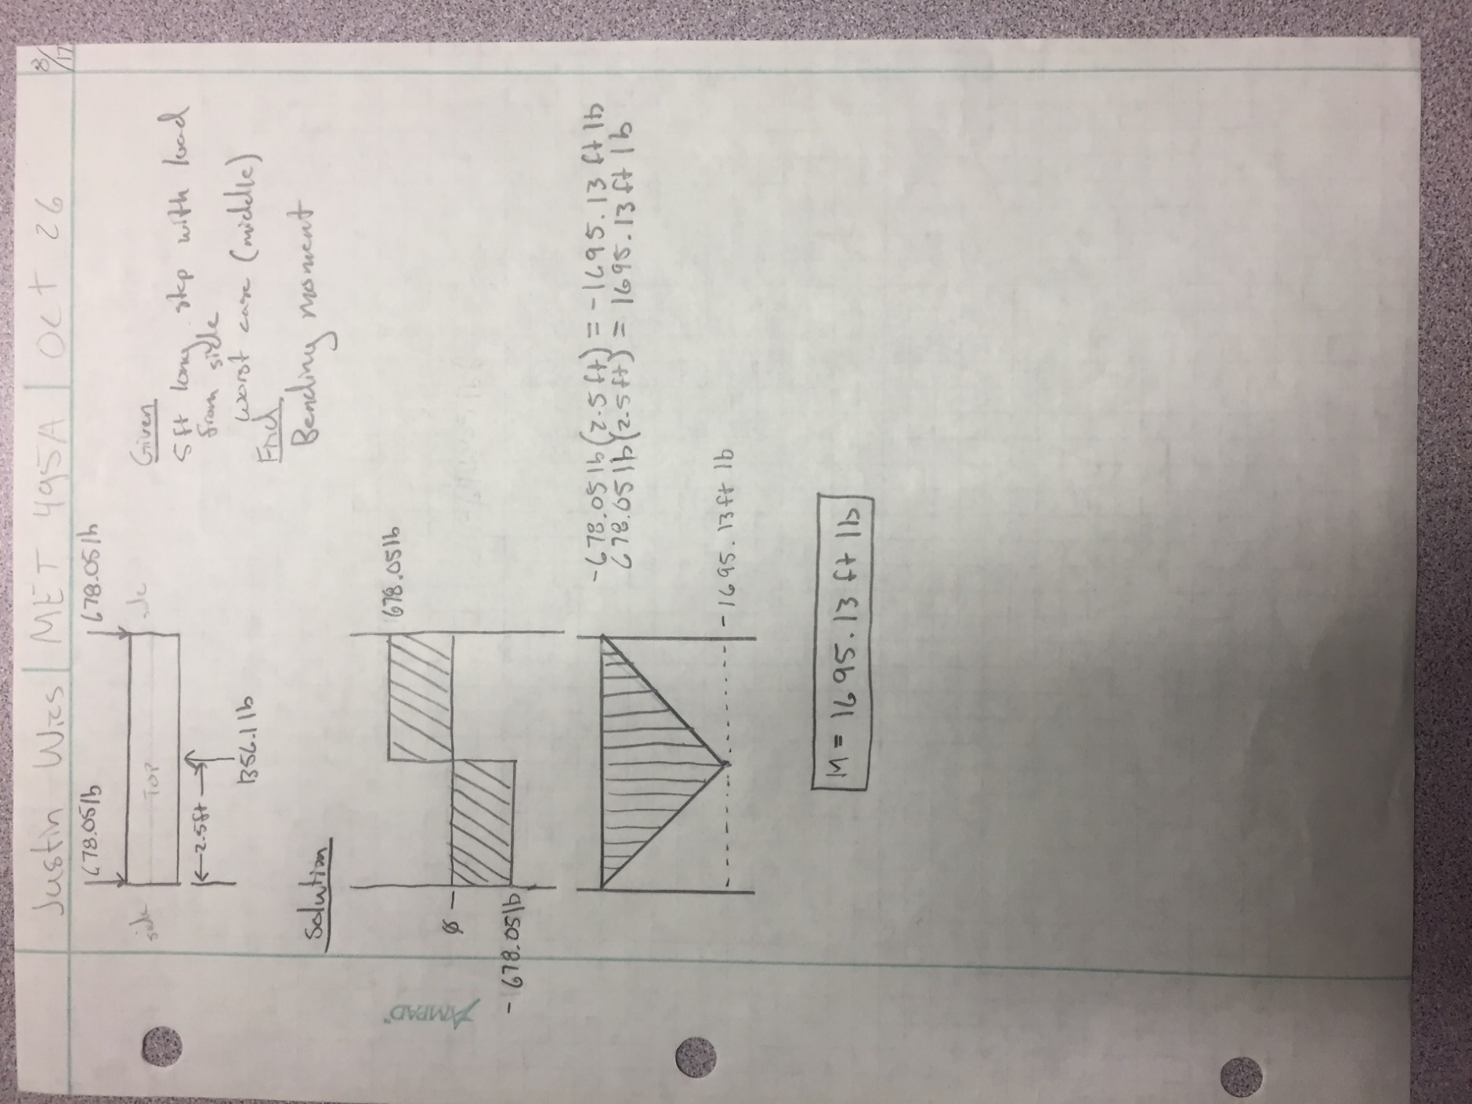
A8: Bending Moment

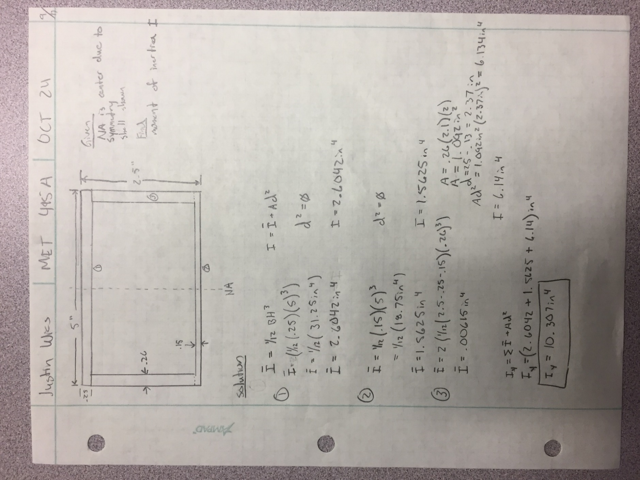
A9: Moment of Inertia I_{y}

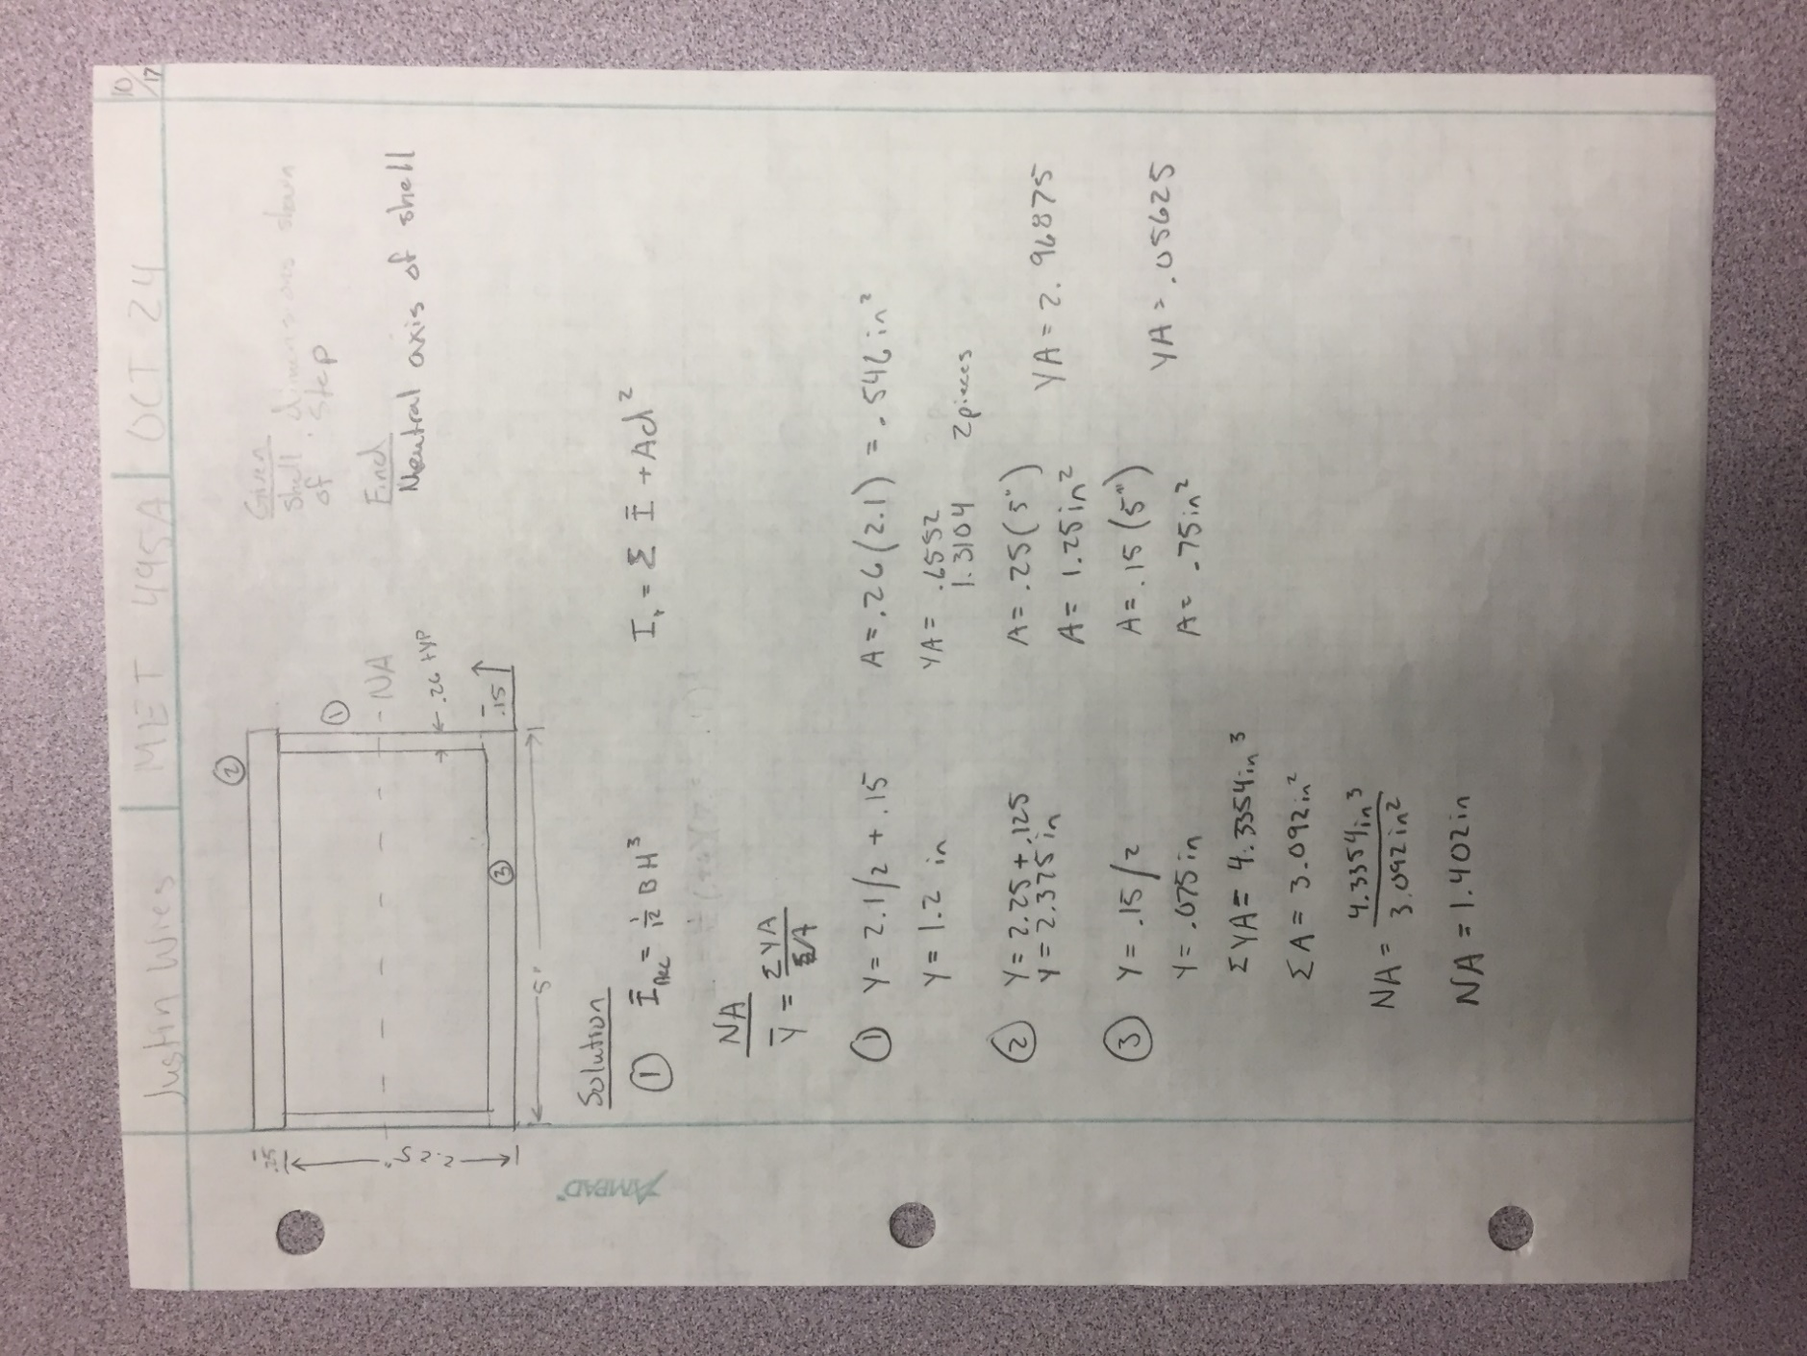
A10: Neutral Axis (NA_{x})

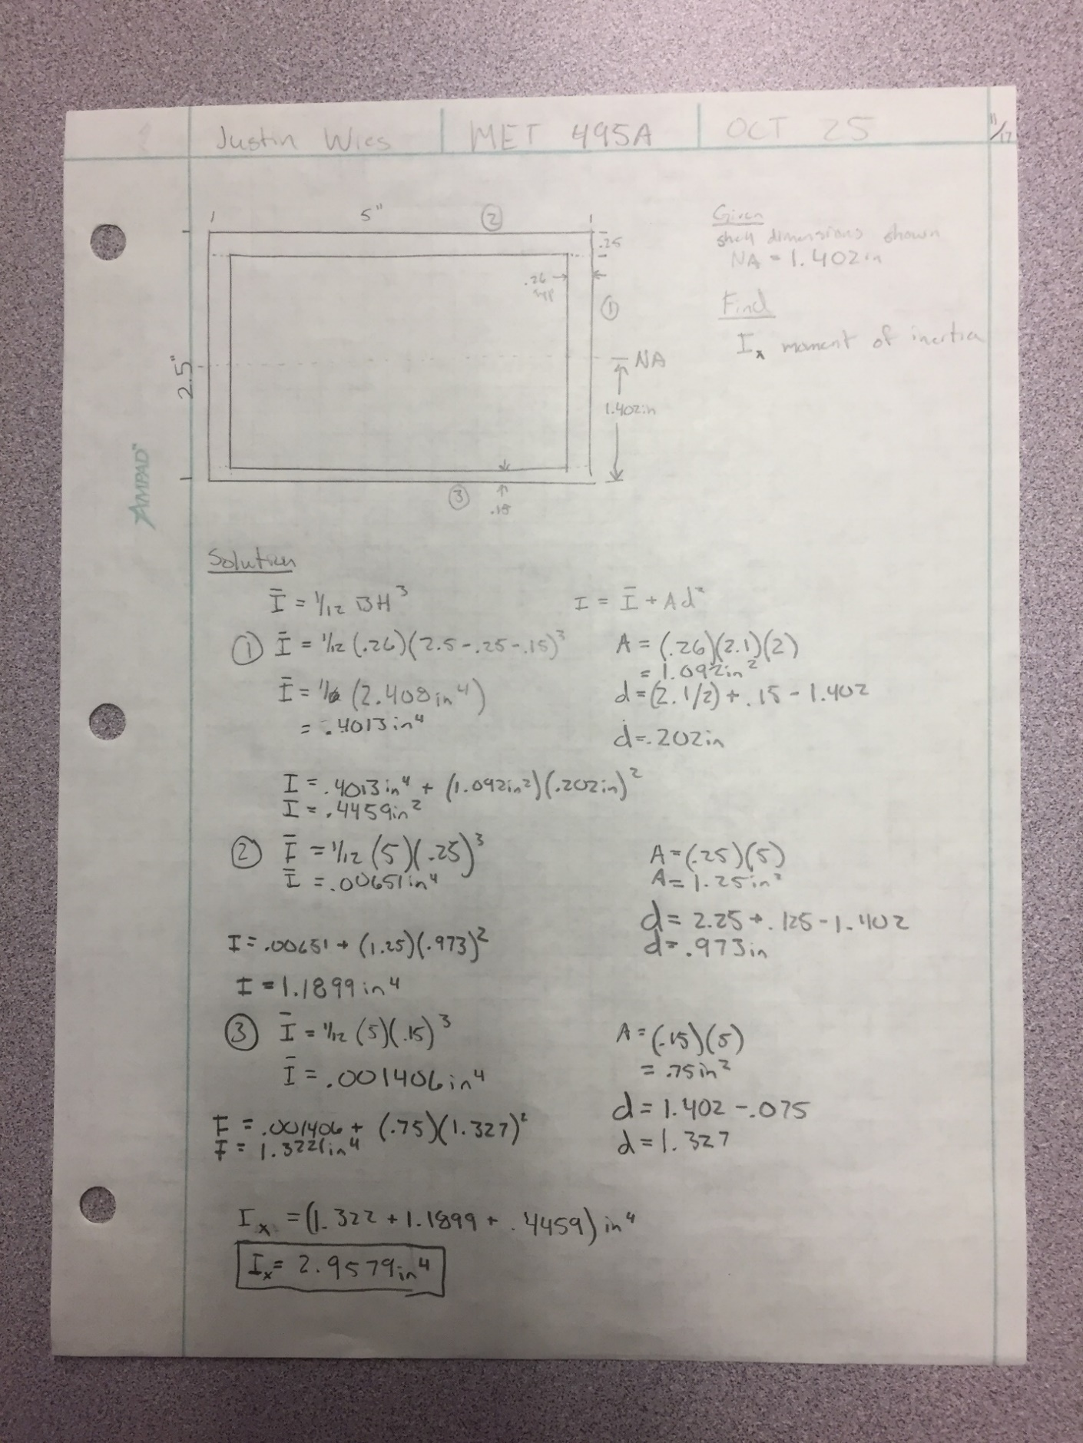
A11: Moment of Inertia I_{x}

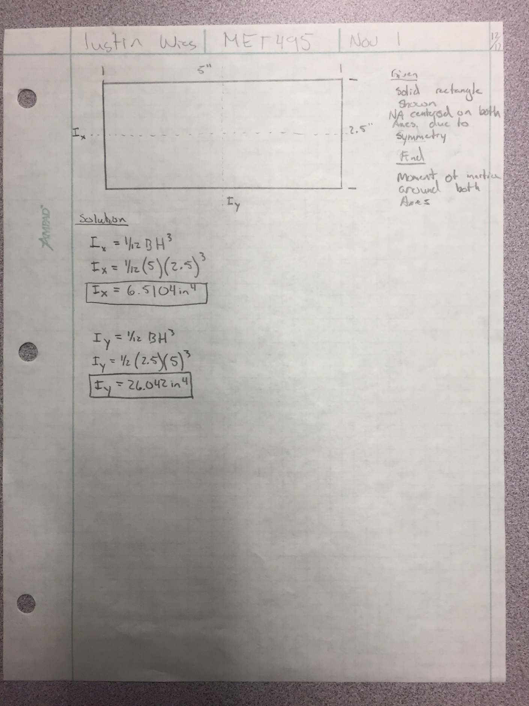
A12: Maximum Moment of Inertia, I_{x} & I_{y}

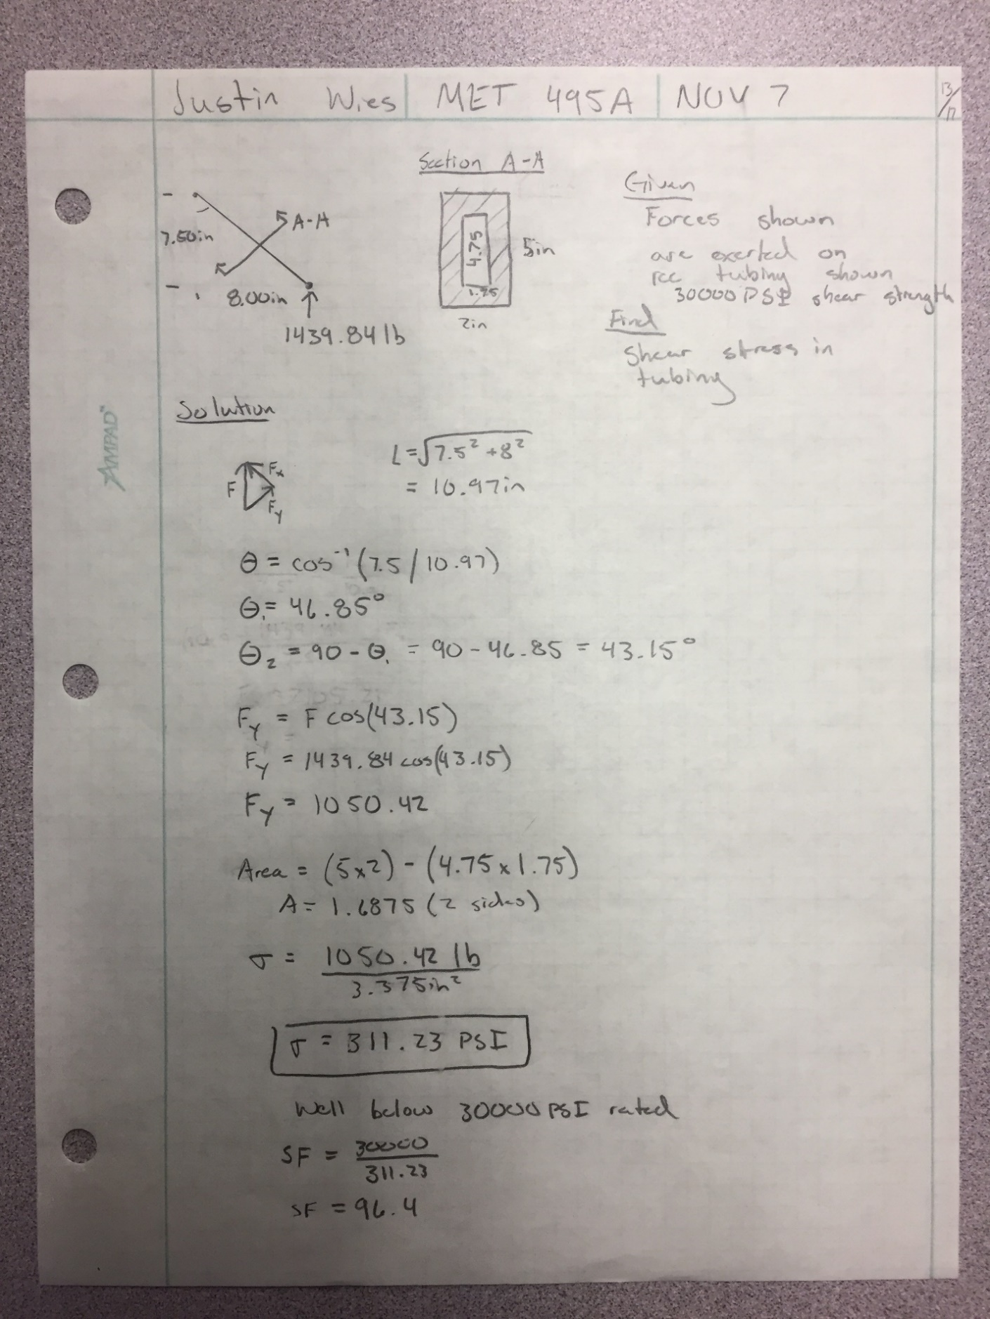
A13: Shear Stress in Side

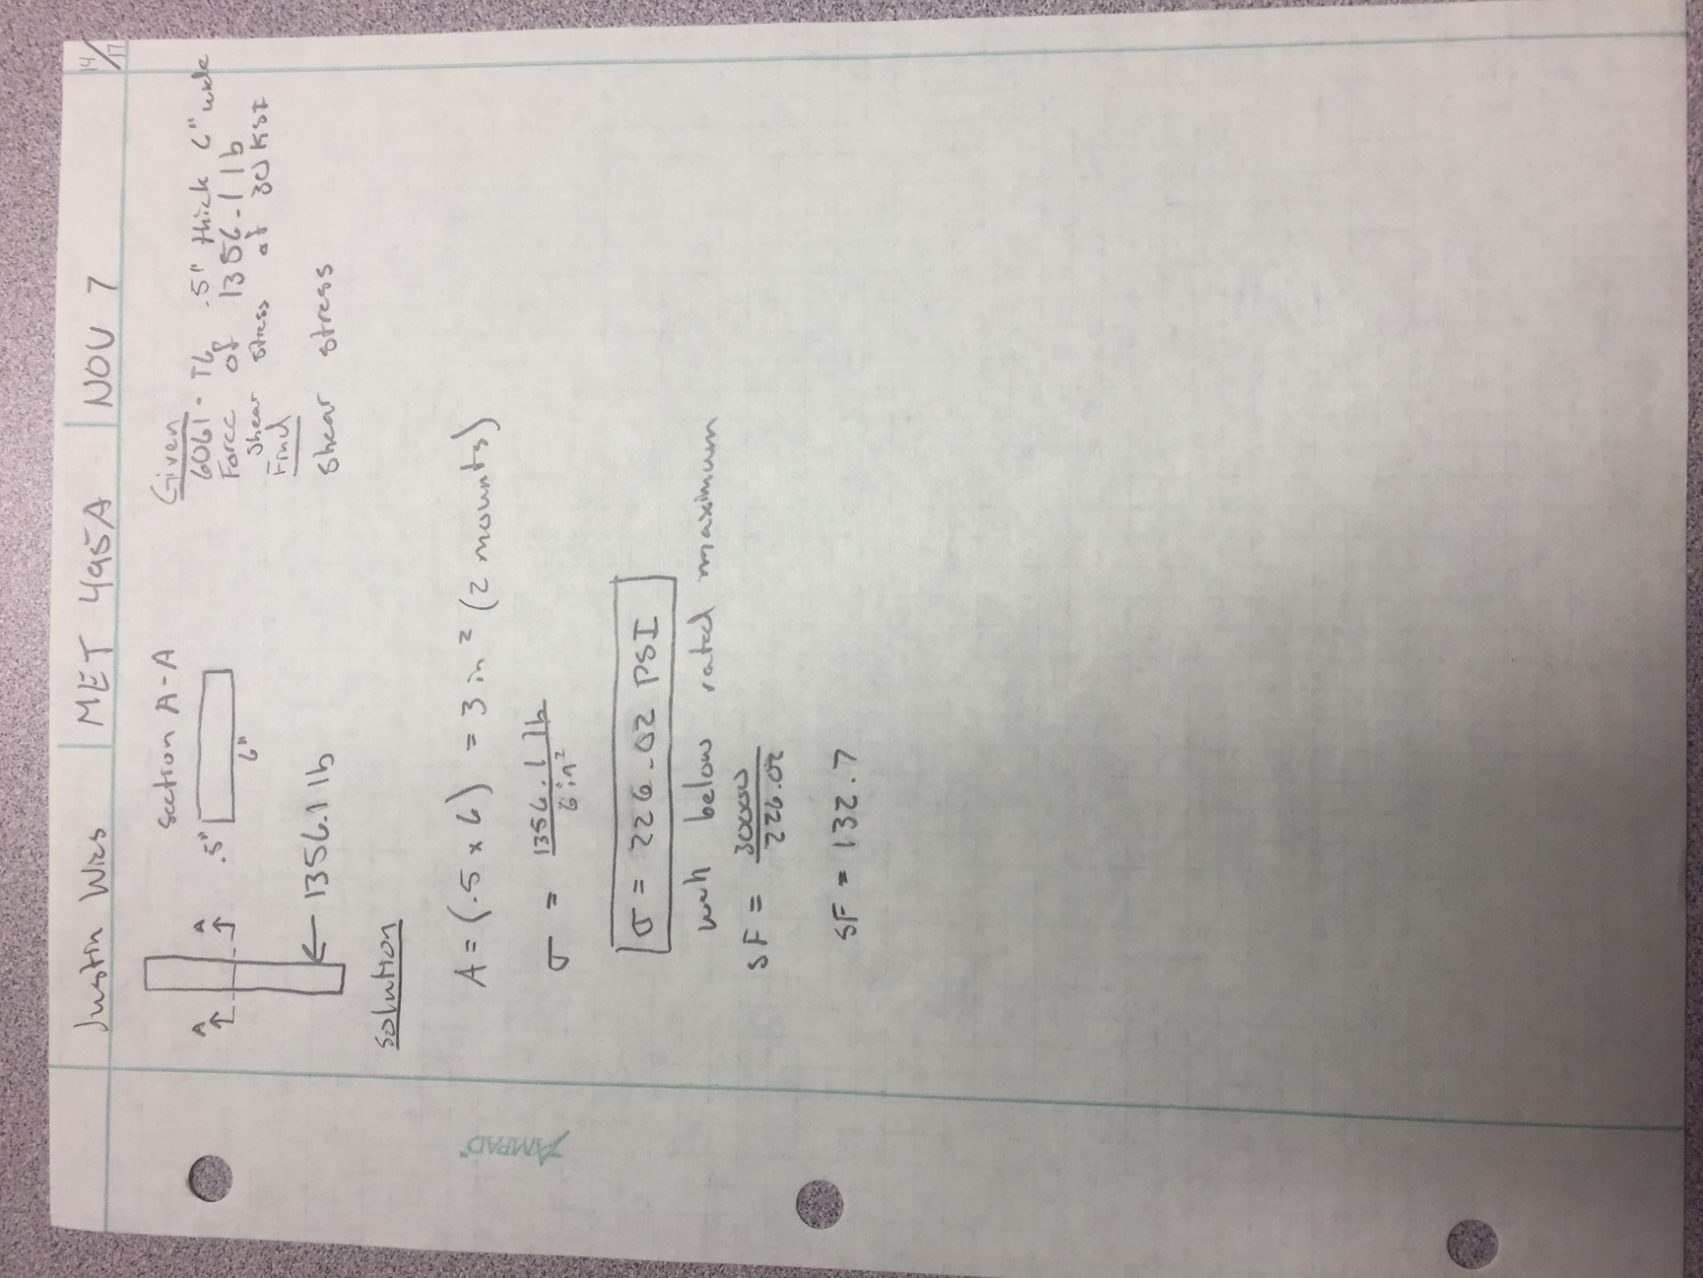
A14: Shear Stress in Mount

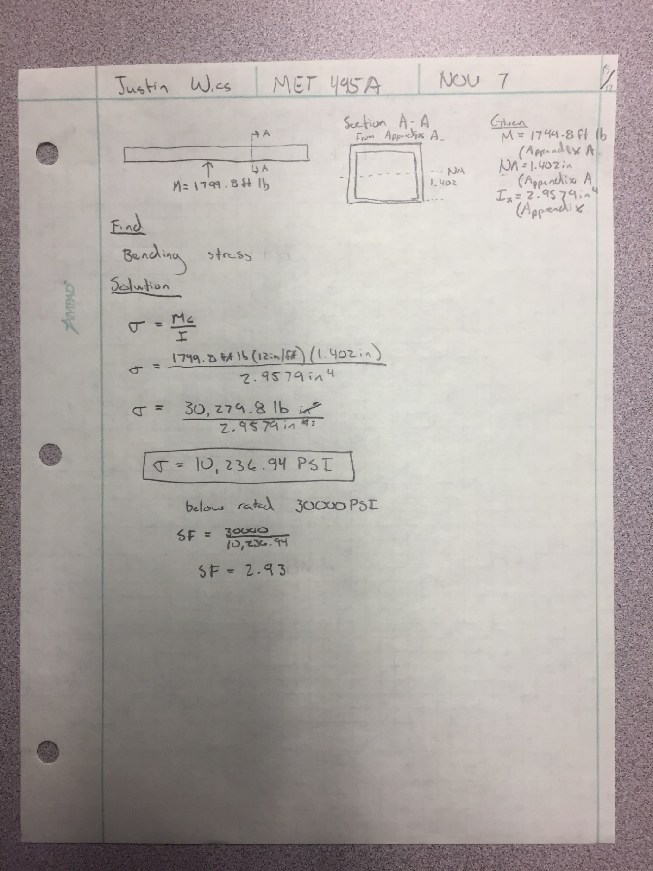
A15: Maximum Bending Stress σ_{x}

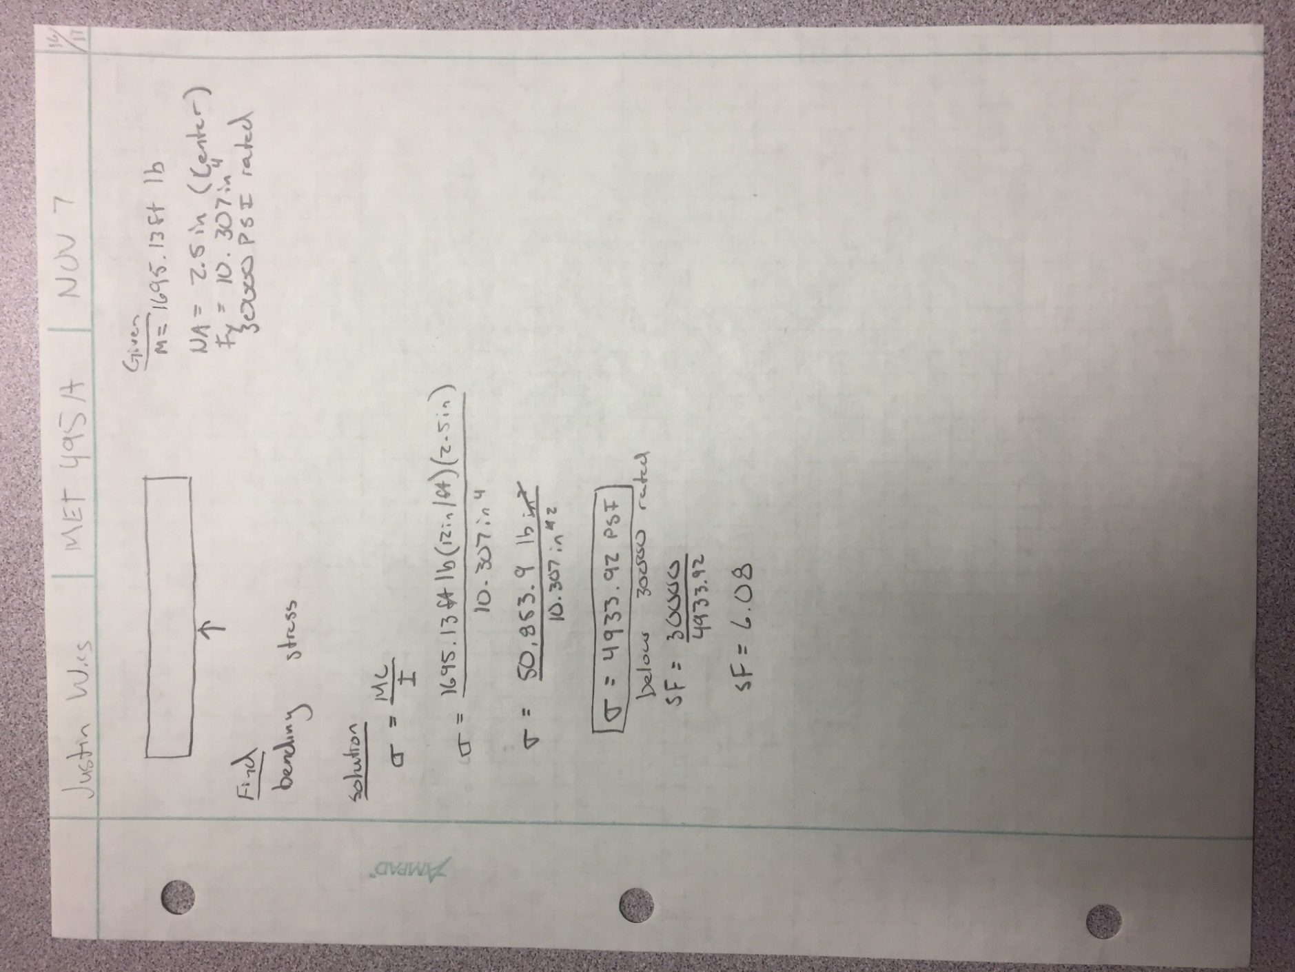
A16: Maximum Bending Stress σ_{y}

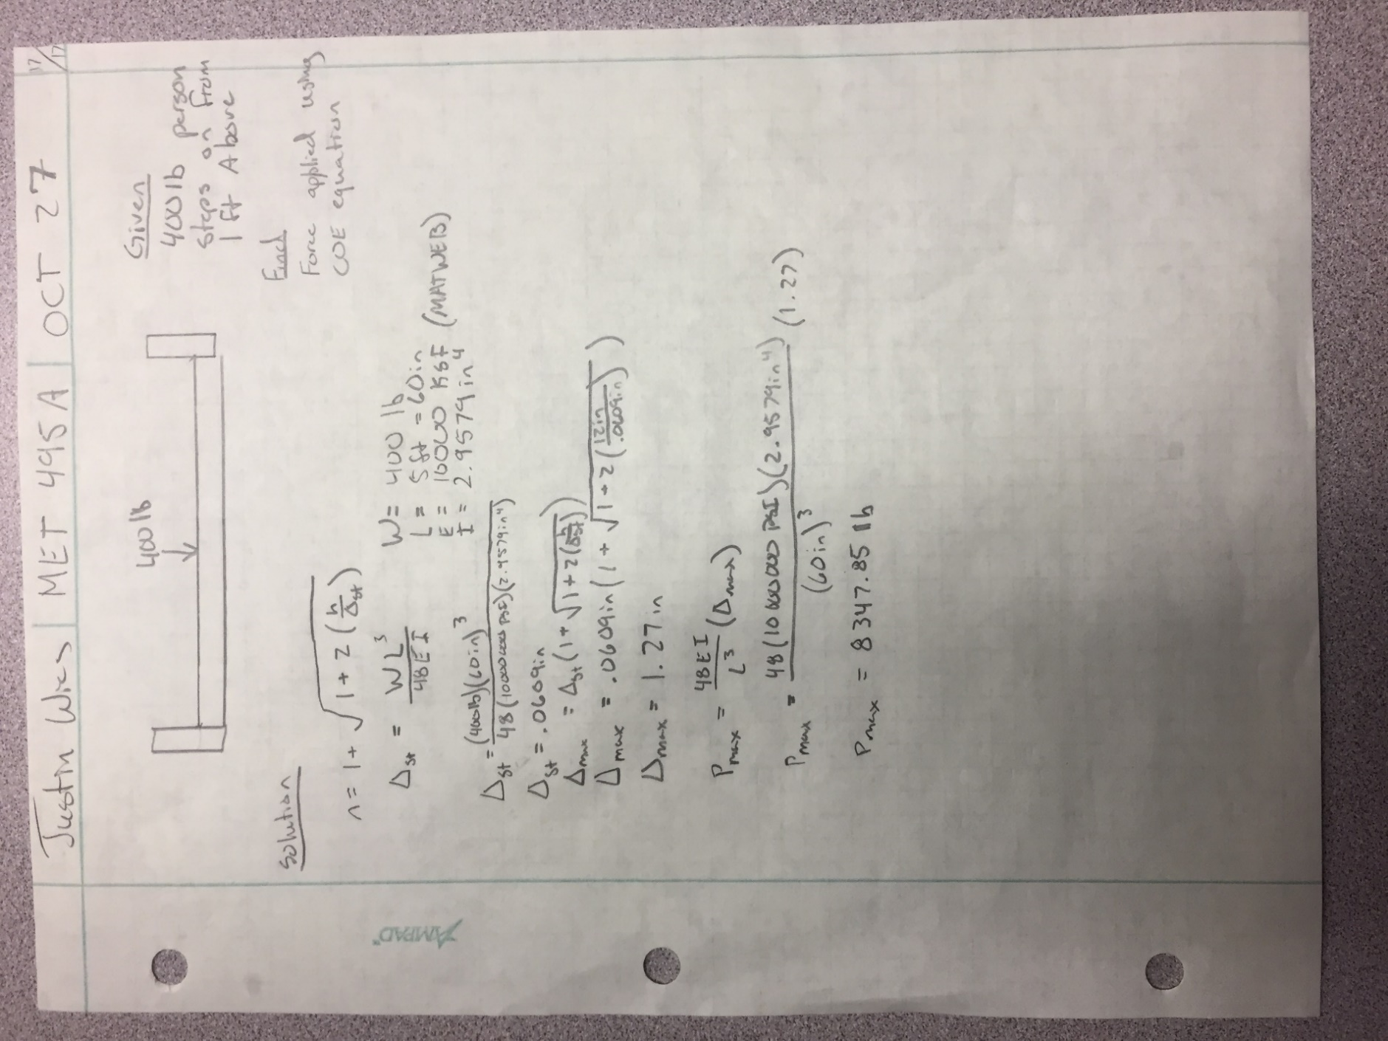
A17: Conservation of Energy Attempt

Appendix B: Drawings

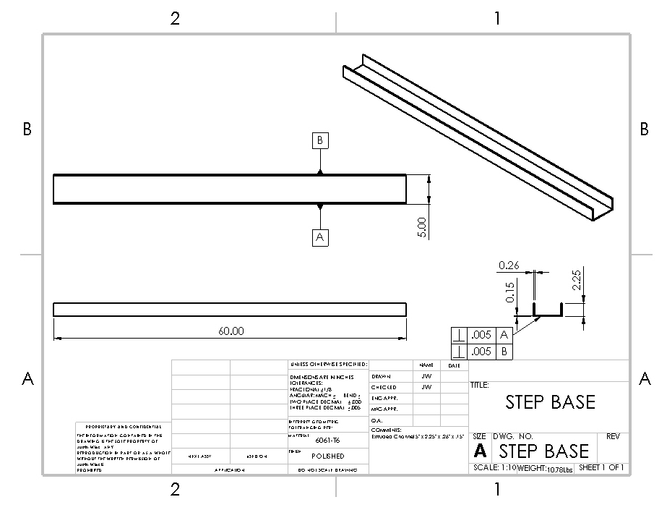
B1: Step Base

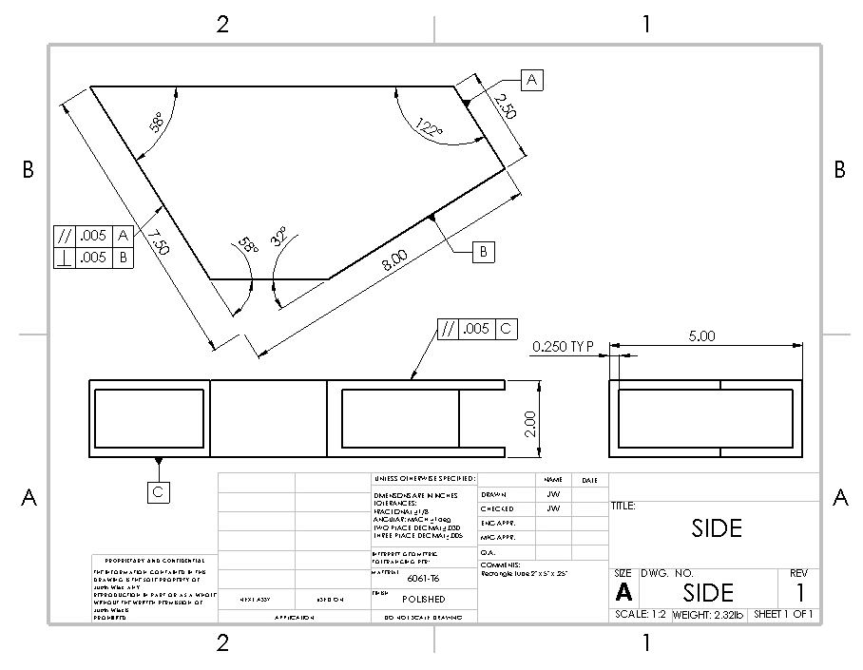
B2: Side

B3: Support
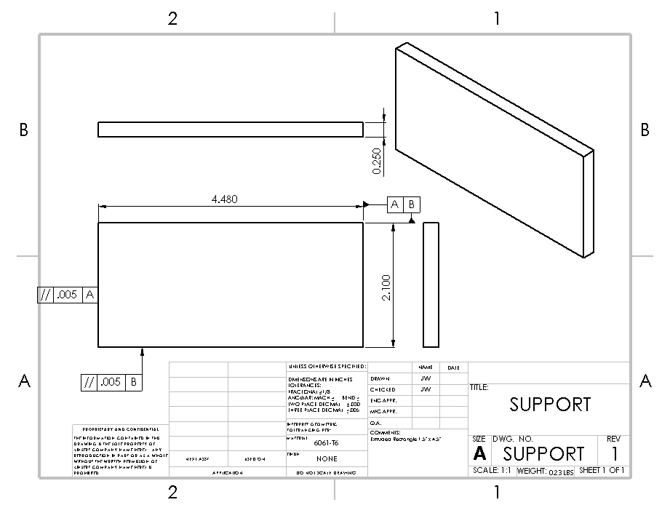

B4: Mount
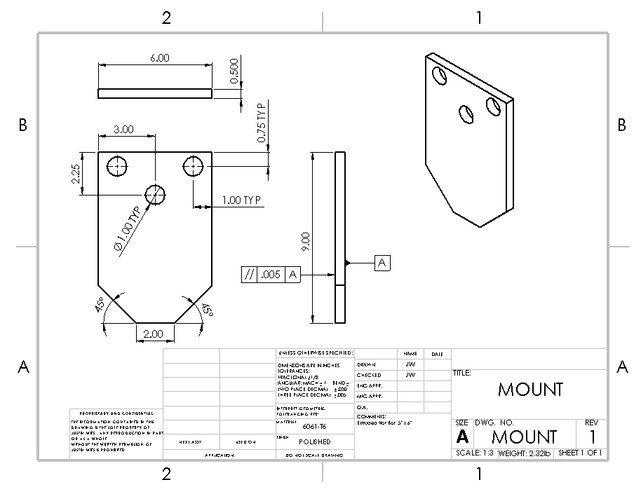

B5: 1’ Flat Bar
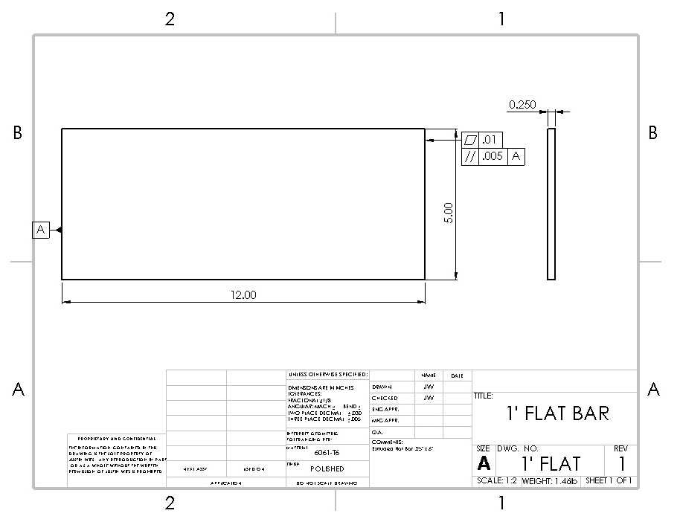

B6: 2’ Flat Bar
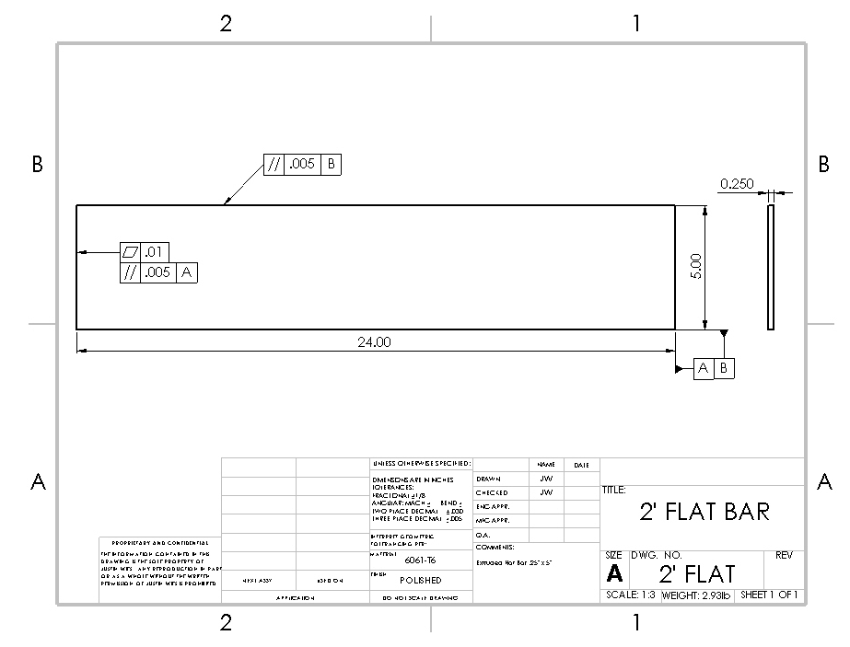

B7: Diamond Plate
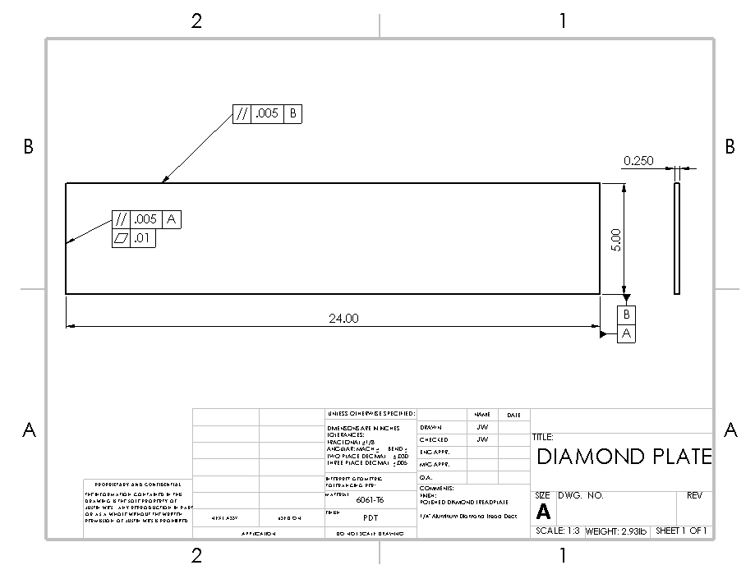

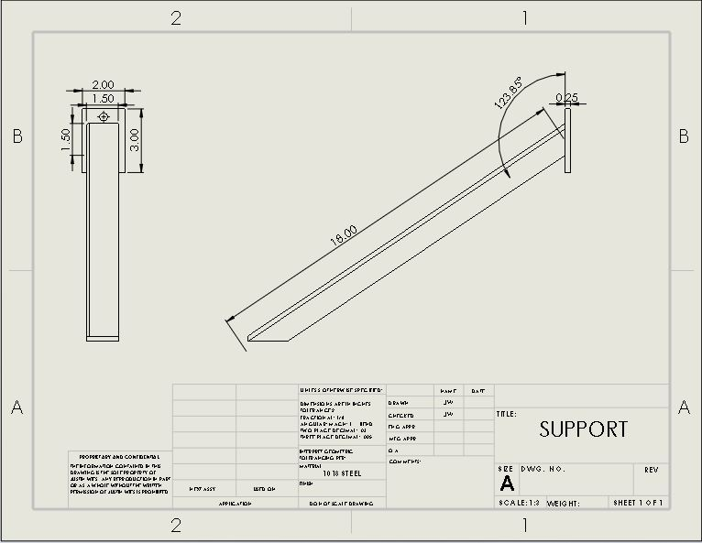
B8: Rear Support

B9: Step Base Assembly 1
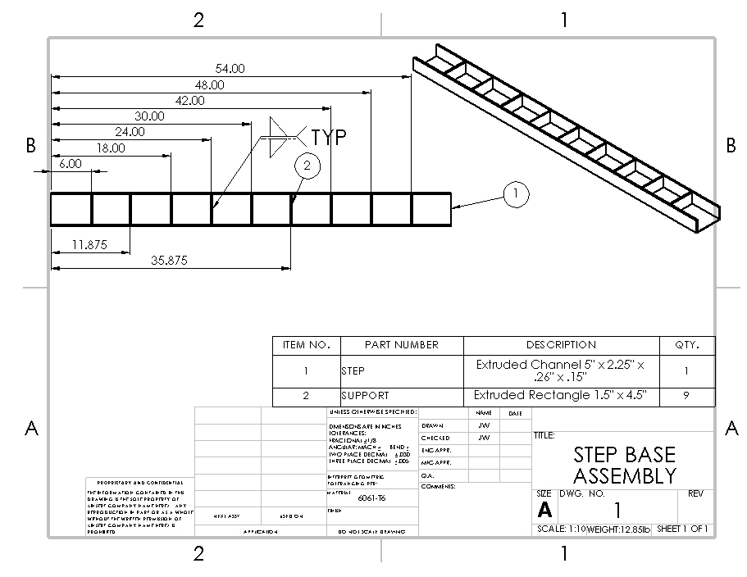

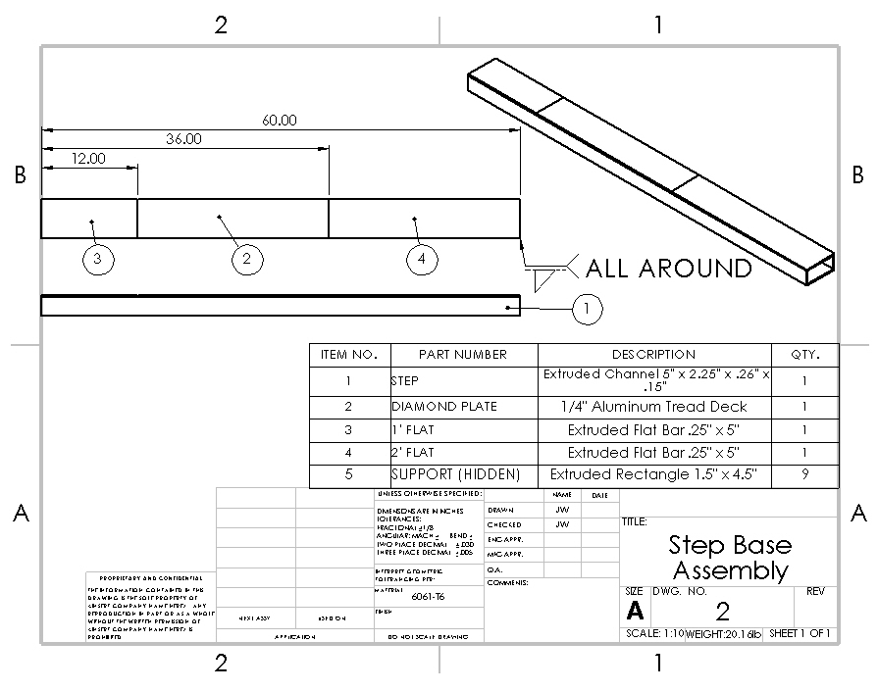
B10: Step Base Assembly 2

B11: Side and Mount Assembly
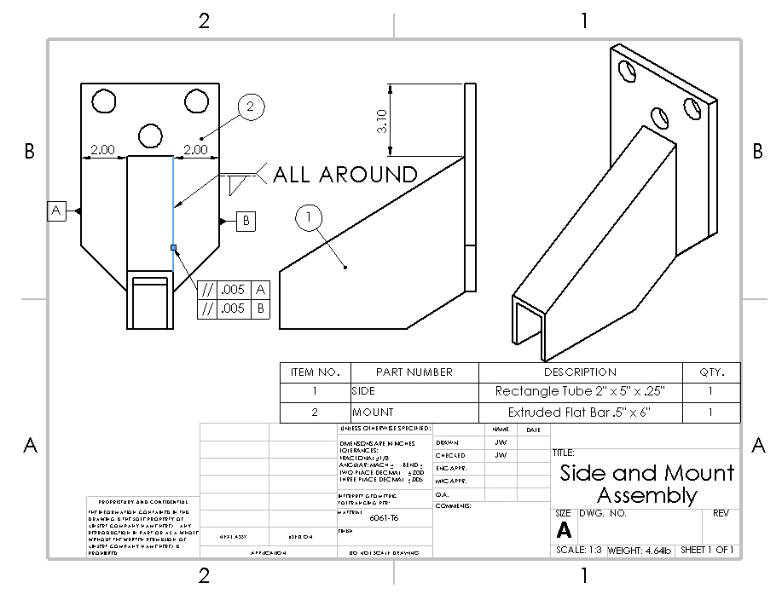

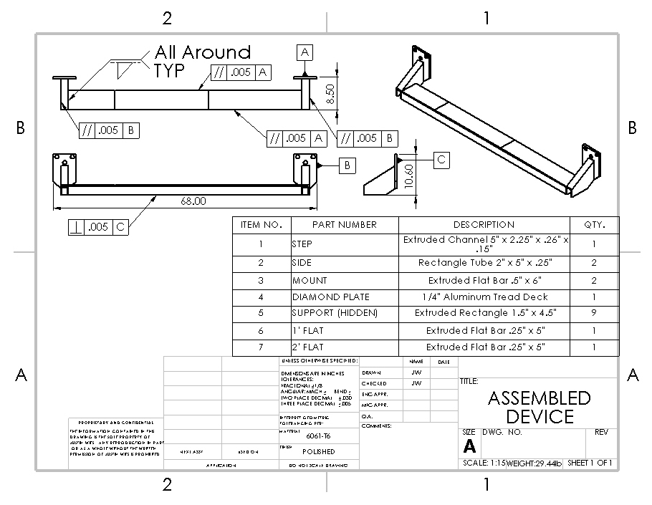
B12: Assembled Device

Appendix C: Parts List

Appendix D: Budget

Appendix E: Schedule

E1: Fall Quarter

E2: Winter Quarter

Appendix J: Resume
1901 N Walnut St. Apt #54
(509) 307-8837
Justin.wies@cwu.edu
Justin Wies
Objective
Results-oriented Mechanical Engineer with a hands-on approach to tackling projects and accomplishing goals.
Experience
Summer Hire Yakima County Public Services Yakima, WA
06/2015 to 12/2016
Use survey equipment to Survey areas, maintain equipment, trucks and trailers, record and report contractor delivered materials, draw pipe drawings, traffic control, and perform manual labor
Read and interpreted blueprints, technical drawings, schematics, specifications, and computer generated reports.
Investigated equipment failures with mechanics to service and repair construction equipment, trucks, and vehicles
Laborer Russ Johnson Excavation Yakima, WA
04/2005 to 11/2014
Investigated equipment failures to diagnose faulty operation and made appropriate maintenance recommendations.
DJ/Floor Guard Skateland Fun Center Yakima, WA
07/2013 to 01/2016
Oversee crowds, maintained safety of patrons, resolved conflicts, and facility/ground maintenance as required.
Education
Central Washington University 2014 to 2017 Ellensburg, WA
Bachelor of Arts: Mechanical Engineering Technology
3.85 GPA
Yakima Valley Community College 2012 to 2014 Yakima, WA
Associate of Science:
East Valley High School 2010 to 2014 Yakima, WA
3.7 GPA
Skills

- Complex problem solving
- Strong decision maker
- Quick learner
- Works well in diverse team environment
- Microsoft Excel, Word, PowerPoint
- SolidWorks 3-D models
- AutoCAD
- Construction Equipment
- Stress analysis training
- Component functions and testing requirements
- Engine components, pumps, and fuel systems knowledge
- Thermodynamics
- Fluid dynamics
- Machining
- CadCAM

